CSS ISLAMIC STUDIES · T6KB
بِسۡمِ ٱللَّهِ ٱلرَّحۡمَٰنِ ٱلرَّحِيمِ
Topic VI — Islam, the West and the Muslim World
The Knowledge Base · The impact of Islamic civilization on the West and vice versa, the role of Islam in the modern world, the Ummah and its challenges, co-existence, Islamophobia, the Two-Nation Theory and the reconstruction of Pakistani society
Eleven chapters built from the syllabus and from the nine questions set on this topic between 2015 and 2026, with the contemporary debates, the examiner's record, five likely questions, a numbered one-liner bank and section-by-section revision notes. Every point carries its evidence — the Quran first, then the Hadith, then history, the scholars and the data — inside the point itself.
Edition of September 2026 · covers the papers of 2015–2026 · written for CSS 2027 and after
Contents
HOW TO BUILD THE CONTENTS
The Contents below is left empty on purpose. In Microsoft Word, right-click anywhere on the grey line below and choose Update Field → Update entire table → OK. The full table of contents with page numbers will appear.
On a Mac: right-click (or Control-click) the line → Update Field. If you edit the notes later, repeat this step to refresh the page numbers. You can also press Ctrl + A then F9 (Windows) to update every field in the document at once.

How to Use This Document 10
What this topic covers 10
How this document is built 11
Part Zero — The ABC Before the Chapters 12
0.1 The words of this topic 12
0.2 The Muslim world in numbers 12
Chapter 1 · The Impact of Islamic Civilization on the West 14
1.1 The background — Europe's 'Dark Ages' and the Muslim golden age 14
1.2 The channels of transmission 15
(1) Spain (Al-Andalus, 711–1492) 15
(2) Sicily and southern Italy 15
(3) The Crusades (1095–1291) 15
(4) Trade 15
1.2a Al-Andalus in close-up — the bridge to Europe 15
1.3 The impact on science and mathematics 16
(1) Numerals, zero and algebra 16
(2) Astronomy 16
(3) Optics and scientific method 16
(4) Chemistry 16
(5) Geography and travel 16
1.4 The impact on medicine 17
1.5 The impact on philosophy and thought 17
1.6 The impact on education and institutions 17
1.7 The impact on daily life, economy and language 17
1.7a Why Islamic civilization could lead — the reasons 18
1.7b The honest limits 18
1.8 What Western scholars say 19
Chapter 2 · The Impact of the West on the Muslim World 20
2.1 How the relationship reversed 20
2.2 The phases of Western influence 20
2.3 The positive influences 21
(1) Modern science and technology 21
(2) Modern education 21
(3) Political and administrative systems 21
(4) Awareness and reform 21
(5) Social change 21
2.4 The negative influences 21
(1) Political 21
(2) Economic 21
(3) Ideological 22
(4) Cultural and social 22
(5) Intellectual 22
2.4a The Muslim responses in history 23
2.4b Western influence in Pakistan today — the visible signs 23
2.4c Globalisation — the newest face of Western influence 24
2.5 The measures to protect Muslim societies 24
(1) The principle — selective acceptance 24
(2) Education 24
(3) The family 24
(4) Media and the digital space 24
(5) Language and identity 25
(6) Economic independence 25
(7) Science and technology 25
(8) Role of scholars and leaders 25
(9) Cooperation among Muslim states 25
Chapter 3 · Muslim Views of Western Civilization 26
3.1 Why Muslims disagree about the West 26
3.2 View 1 — Total rejection (the defensive-traditional view) 26
(1) The view 26
(2) Its roots 26
(3) Analysis 26
3.3 View 2 — Total acceptance (the Westernising view) 27
(1) The view 27
(2) Its advocates 27
(3) Analysis 27
3.4 View 3 — Synthesis (the reformist view) 27
(1) The view 27
(2) Its advocates 27
(3) Analysis 27
3.5 View 4 — Critical engagement (the civilizational critique) 27
(1) The view 27
(2) Its advocates 28
(3) Analysis 28
3.6 View 5 — Dialogue and co-existence 28
(1) The view 28
(2) Examples 28
(3) Analysis 28
3.7 View 6 — The conspiracy view 28
(1) The view 28
(2) Analysis 28
3.8 The comparative analysis 29
3.8a The views in Pakistan today 29
3.9 The balanced Islamic position 29
Chapter 4 · Islamic Ideology and Modern Western Thought: Individuality 31
4.1 Individuality and individualism — the terms 31
4.2 The rise of Western individualism 31
4.3 The present trends of individuality in the West 31
4.4 The Islamic view of the individual 32
(1) Dignity of each person 32
(2) Individual responsibility 32
(3) The individual as a trustee, not an owner 32
(4) Freedom within limits 33
(5) The individual within the community 33
(6) Rights joined with duties 33
(7) Worship that joins the individual to the group 33
4.5 Iqbal: Khudi and Bekhudi 34
4.6 The comparison 34
4.7 What Islam appreciates in Western individuality 34
4.7a The consequences of extreme individualism — what the evidence shows 34
4.8 The present trend among Muslims 35
Chapter 5 · The Role of Islam in the Modern World 36
5.1 The problems of modern man 36
5.2 Islam's answers 37
(1) Meaning and peace — the spiritual answer 37
(2) A stable family 37
(3) Economic justice 37
(4) Care of the environment 37
(5) Equality against racism 38
(6) Peace and the ethics of war 38
(7) Moral absolutes with flexibility 38
(8) Knowledge with ethics 38
5.2a Islam and the modern ideologies 38
5.2b Islam's appeal in the modern world — the evidence 39
5.2c Islam, science and technology today 39
5.3 The Muslim world's role — the middle nation 40
Chapter 6 · The Muslim Ummah: Concept, Structure and Revival 42
6.1 The concept of the Ummah 42
(1) The word 42
(2) One Ummah under one Lord 42
(3) Its qualities 42
(4) Brotherhood — the bond 43
(5) The Ummah is not racial nationalism 44
6.2 The structure of the Ummah 44
(1) The spiritual structure 44
(2) The social structure 44
(3) The political structure 44
(4) The economic structure 45
(5) The cultural and educational structure 45
6.3 The history — rise and decline 45
(1) Rise 45
(2) The causes of decline 45
6.3a The movements for Muslim unity 45
6.3b The OIC — achievements and failures 46
6.3c Iqbal's vision of the Ummah 46
6.4 Suggestions for the revival of the Ummah 46
(1) Return to the Quran and Sunnah — with ijtihad 46
(2) Unity above sect and nation 47
(3) Knowledge, science and technology 47
(4) Good governance and justice 47
(5) Economic integration 47
(6) Defence and security cooperation 48
(7) A reformed OIC 48
(8) Media and the youth 48
(9) Moral and spiritual renewal 48
Chapter 7 · The Muslim World: Contemporary Challenges and Solutions 50
7.1 Political challenges 50
7.2 Economic challenges 50
7.3 Educational and scientific challenges 50
7.4 Security challenges 51
7.5 Social challenges 51
7.6 Cultural and ideological challenges 51
7.7 External challenges 51
7.8 Environmental challenges 51
7.8a Pakistan's role in the Muslim world 51
7.8b Case note — Palestine 52
7.9 Solutions in the light of the Quran and Sunnah 52
Chapter 8 · Co-existence in a Multi-faith Society 54
8.1 The meaning 54
8.2 The Quranic principles of co-existence 54
(1) Diversity is Allah's will 54
(2) No compulsion 54
(3) Freedom of belief with clarity of identity 55
(4) Kindness and justice to peaceful non-Muslims 55
(5) Respect for what others hold sacred 55
(6) Dialogue in the best manner 55
(7) Protection of all places of worship 56
(8) One human family 56
8.3 The Prophetic model 56
8.4 The historical record 57
8.5 The rights of non-Muslims in an Islamic state 57
8.6 Modern declarations 57
8.7 Co-existence in Pakistan 57
Challenges 58
Solutions 58
8.8 Muslims as minorities — the principles 58
8.9 Tools of interfaith harmony 58
Chapter 9 · Islamophobia: Causes and Remedies 60
9.1 The meaning 60
9.2 Its forms 60
9.3 The causes 60
9.4 'Islamophobia is a sign of extremism' 60
(1) Islamophobia is itself extremism 60
(2) It feeds, and is fed by, Muslim extremism 61
(3) The Quranic rule — no collective guilt 61
9.5 The remedies 62
(1) International action 62
(2) Legal measures 62
(3) Education and dialogue 62
(4) Media engagement 62
(5) Muslims' own conduct — the most powerful remedy 62
(6) Answering insults the Prophetic way 63
9.6 Islamophobia and the Muslim diaspora — the positive record 63
Chapter 10 · The Two-Nation Theory and the Muslims of India and Kashmir 64
10.1 The Two-Nation Theory — meaning 64
10.2 The Islamic basis 64
10.3 The historical development 65
(1) Early recognition 65
(2) Sir Syed Ahmad Khan 65
(3) The All-India Muslim League (Dhaka, 1906) and separate electorates (1909) 65
(4) Allama Iqbal — the Allahabad Address (1930) 65
(5) Quaid-e-Azam — the Lahore Resolution (23 March 1940) 66
10.4 The justification of the theory 66
10.5 The plight of Indian Muslims — the theory confirmed 66
10.6 The plight of Kashmiri Muslims 67
10.7 The demands of the Two-Nation Theory today 67
10.7a The Two-Nation Theory and the Quaid's speech of 11 August 1947 67
10.7b What the leaders said about Pakistan's ideology 68
10.8 The objections and their answers 68
Chapter 11 · The Reconstruction of Pakistani Society in the Light of Islamic Teachings 69
11.1 The meaning of reconstruction 69
11.2 The constitutional foundation 69
11.3 The problems to be solved 69
11.4 Reconstruction — area by area 69
(1) The individual — tazkiyah and character 69
(2) The family 70
(3) Education 70
(4) The economy 70
(5) Justice and rule of law 71
(6) Governance and accountability 71
(7) Social harmony 71
(8) Women and youth 72
(9) Media and culture 72
(10) The environment 72
11.4a The roles of the key actors 72
11.4b A staged roadmap 72
11.5 The model — the society of Madinah 72
Part Two — Contemporary Challenges, Narratives and Hot Debates 74
12.1 The clash of civilizations or the dialogue of civilizations? 74
12.2 Palestine and Gaza 74
12.3 Kashmir, the Rohingya and Muslims in India 74
12.4 The OIC — potential and weakness 74
12.5 Western cultural influence, brain drain and technological dependence 74
12.6 Artificial intelligence and the Muslim world 75
Part Three — The Examiner's Record and Five Likely Questions 76
13.1 Every question on this topic, 2015–2026 76
13.2 What the record teaches 76
13.3 Five likely questions 76
Part Four — The One-Liner Bank 77
One-liners · Islam's impact on the West 77
One-liners · The West's impact and Muslim views 77
One-liners · Individuality and the role of Islam 78
One-liners · The Ummah and its challenges 78
One-liners · Co-existence and Islamophobia 79
One-liners · Two-Nation Theory and Pakistan 79
Part Five — Revision Notes · Topic 6 81
R6.0 The whole topic in one picture 81
R6.1 Chapter 1 · Islam's impact on the West (due) 81
1.1 Background 81
1.2 Channels (draw the figure) 81
1.2a Al-Andalus close-up 81
1.3 Science 81
1.4 Medicine 82
1.5 Philosophy 82
1.6–1.7 Education and daily life 82
1.7a–b Why it led — and why it stopped 82
1.8 Testimony 82
R6.2 Chapter 2 · The West's impact on Muslims (2026) 82
2.1 Reversal 82
2.2 Phases 82
2.3 Gains 82
2.4 Losses 82
2.4a–c Responses, Pakistan today, globalisation 83
2.5 Protective measures (nine) 83
R6.3 Chapter 3 · Muslim views of the West (2025) 83
R6.4 Chapter 4 · Individuality (2015) 83
R6.5 Chapter 5 · Role of Islam today (likely) 84
R6.6 Chapter 6 · The Ummah (2015) 84
R6.7 Chapter 7 · Challenges and solutions (2016) 85
R6.8 Chapter 8 · Co-existence (2021) 85
R6.9 Chapter 9 · Islamophobia (2021) 85
R6.10 Chapter 10 · The Two-Nation Theory (2026) 86
R6.11 Chapter 11 · Reconstruction of Pakistani society (2022) 86
R6.12 Part Two · Today 87
R6.13 The figures to draw in the paper 87

How to Use This Document

What this topic covers
Topic 6 carries the syllabus lines 'Impact of Islamic civilization on the West and vice versa', 'The role of Islam in the modern world' and 'Muslim world and the contemporary challenges'. The examiner has turned these three lines into nine questions: Islam and the West three times, the Ummah twice, co-existence, Islamophobia, and two Pakistan-centred questions.
Syllabus line / past question | Where it is taught
Impact of Islamic civilization on the West (never asked — due) | Chapter 1
Impact of the West on the Muslim world; protecting Muslim societies (2026) | Chapter 2
Views about Western civilization in Muslim circles (2025) | Chapter 3
Islamic ideology and Western thought on individuality (2015) | Chapter 4
The role of Islam in the modern world (never asked directly) | Chapter 5
Concept, structure and revival of the Ummah (2015) | Chapter 6
Contemporary challenges of the Muslim world and their solutions (2016) | Chapter 7
Co-existence in a multi-faith society (2021) | Chapter 8
Islamophobia and its remedy (2021) | Chapter 9
The Two-Nation Theory and Indian and Kashmiri Muslims (2026) | Chapter 10
Reconstruction of Pakistani society (2022) | Chapter 11

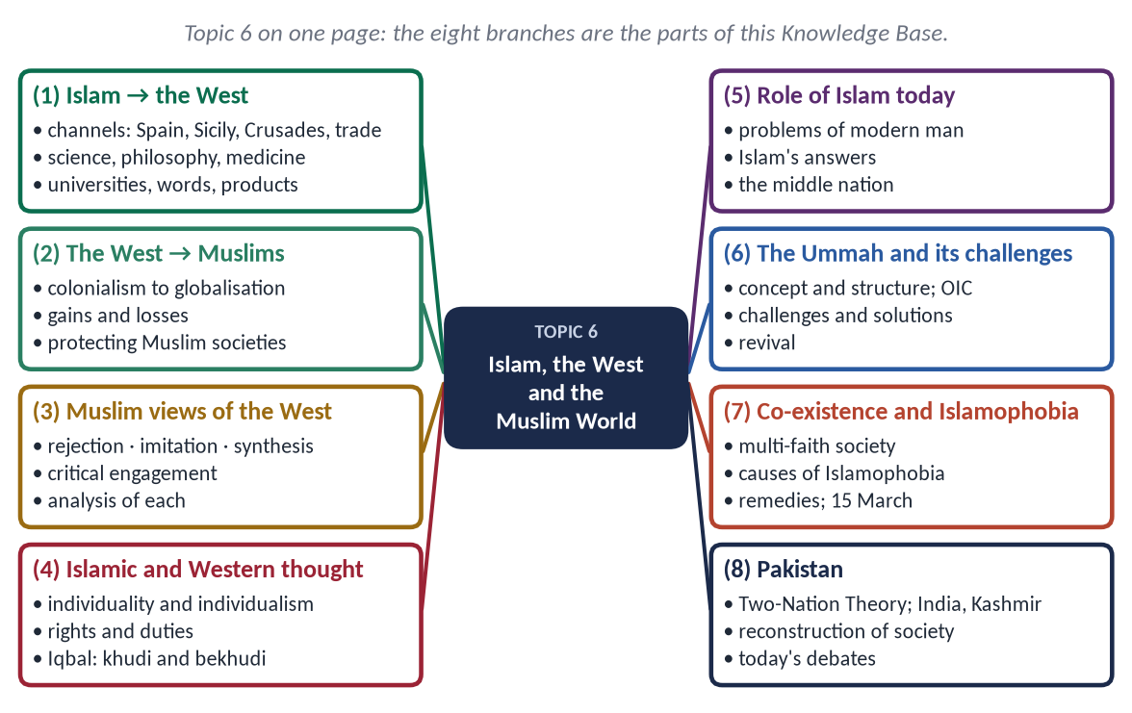
Figure 1 · Topic 6 on one page. The eight branches are the parts of this Knowledge Base.

How this document is built
1. Part Zero — the ABC: the words of the topic and the Muslim world in numbers.
2. Part One — eleven chapters; in every point the evidence comes Quran → Hadith → history → scholars and data.
3. At-a-glance charts after long sections — the names only.
4. Part Two — contemporary challenges and hot debates.
5. Part Three — the examiner's record and five likely questions.
6. Part Four — the numbered one-liner bank.
7. Part Five — section-by-section revision notes.
EXAMINER'S EYE · THIS TOPIC IN THE PAPER
This is the most current-affairs-driven topic of the paper. The examiner wants analysis with facts: dates, organisations, resolutions, numbers — and a balanced tone. Two patterns stand out: Islam and the West (2015, 2025, 2026) and Pakistan's own identity and society (2022, 2026). The first half of the syllabus line — Islam's impact on the West — has never been asked and is due.

TRAP · FACTS, NOT FEELINGS
On Palestine, Kashmir, Indian Muslims and Islamophobia, write firmly but factually: dates, UN resolutions, court judgments, laws, reports. Avoid abusive words about any country, religion or people. A calm, evidence-based answer is the one that scores.

Part Zero — The ABC Before the Chapters

0.1 The words of this topic
Term | Arabic / Urdu | Meaning in this topic
Ummah | أُمَّة | The worldwide community of Muslims; from umm, mother and purpose.
Ummatan wasatan | أُمَّةً وَسَطًا | A middle, balanced nation (Al-Baqarah 143).
Khayra ummah | خَيْرَ أُمَّة | The best nation raised for mankind (Aal-e-Imran 110).
Ukhuwwah | أُخُوَّة | Brotherhood of the believers.
Wahdah | وَحْدَة | Unity.
Tajdid / Islah | تَجْدِيد / إِصْلَاح | Renewal / reform.
Ijtihad | اِجْتِهَاد | Independent legal reasoning — the principle of movement (Iqbal).
Taqlid | تَقْلِيد | Following a school without independent reasoning.
Istishraq | اِسْتِشْرَاق | Orientalism — Western study of the East.
Ta'ayush | تَعَايُش | Co-existence.
Hiwar | حِوَار | Dialogue.
Du-Qaumi Nazariyah | دو قومی نظریہ | The Two-Nation Theory (Urdu).
Islamophobia | — | Irrational fear of, hostility to, or discrimination against Islam and Muslims.
Individualism | — | The Western view that the individual is the centre and measure of value.

0.2 The Muslim world in numbers
Fact | Figure
Muslims in the world | about 2 billion — roughly one in four people (Pew)
Members of the OIC | 57 states on four continents
OIC founded | 1969, Rabat, after the arson at Al-Aqsa; renamed Organisation of Islamic Cooperation in 2011; secretariat in Jeddah
Share of world GDP | well below its share of population (roughly 8–9 percent of world GDP)
Largest Muslim country | Indonesia; second: Pakistan; India has about 200 million Muslims
Islamic Development Bank | founded 1975, Jeddah
Refugees | a large share of the world's refugees come from Muslim-majority countries (Syria, Afghanistan, Sudan, the Rohingya)

Chapter 1 · The Impact of Islamic Civilization on the West
The first half of the syllabus line — never asked, and therefore due.

1.1 The background — Europe's 'Dark Ages' and the Muslim golden age
From the 8th to the 13th century, while much of Europe was in its early medieval period, the Muslim world from Cordoba to Baghdad and Samarkand was the leading centre of science, philosophy and learning. Muslims preserved, translated, corrected and advanced the knowledge of Greece, Persia and India, and then passed it to Europe.
✦ QURAN
﴿ٱقۡرَأۡ بِٱسۡمِ رَبِّكَ ٱلَّذِي خَلَقَ ۝ خَلَقَ ٱلۡإِنسَٰنَ مِنۡ عَلَقٍ ۝ ٱقۡرَأۡ وَرَبُّكَ ٱلۡأَكۡرَمُ ۝ ٱلَّذِي عَلَّمَ بِٱلۡقَلَمِ ۝ عَلَّمَ ٱلۡإِنسَٰنَ مَا لَمۡ يَعۡلَمۡ﴾
“Recite in the name of your Lord who created. Created man from a clinging substance. Recite, and your Lord is the most Generous. Who taught by the pen. Taught man that which he knew not.” (Al-Alaq, Quran)
➜ 'Read in the name of your Lord … who taught by the pen, taught man what he did not know' — a civilization founded on a command to read.

✦ HADITH
طَلَبُ الْعِلْمِ فَرِيضَةٌ عَلَى كُلِّ مُسْلِمٍ
“Seeking knowledge is an obligation upon every Muslim.” (Ibn Majah)
➜ Knowledge as worship produced a scientific culture.

1.2 The channels of transmission
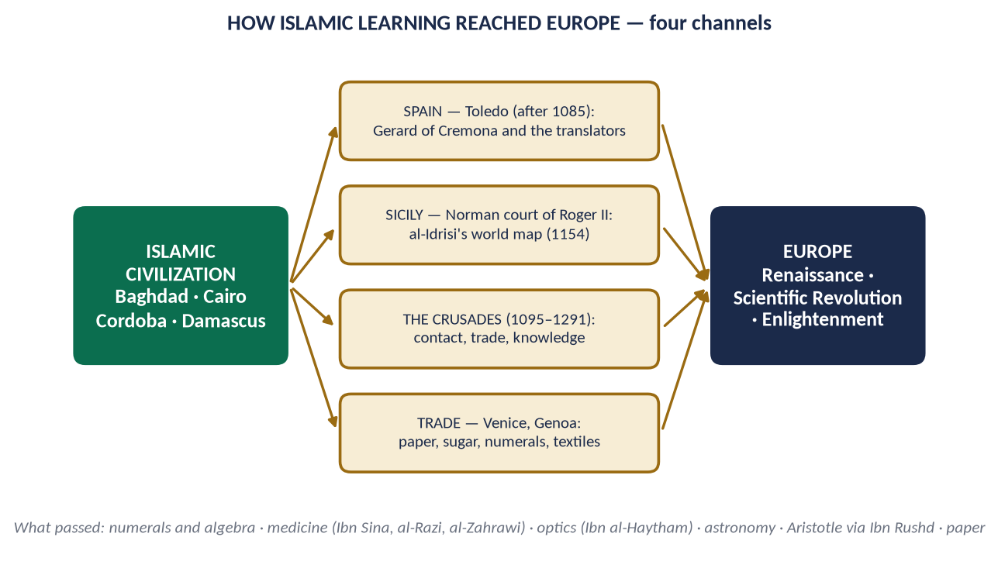
Figure 2 · How Islamic learning reached Europe: four channels.

(1) Spain (Al-Andalus, 711–1492)
- Cordoba under the Umayyad Caliphate (929–1031) was the largest and most learned city of Western Europe — paved and lit streets, public baths, a library of about 400,000 volumes.
- After Christians took Toledo (1085), it became a centre of translation from Arabic into Latin; Gerard of Cremona (d. 1187) alone translated some eighty-seven works, including Ibn Sina's Canon and Ptolemy's Almagest from Arabic.
- European students — among them Gerbert of Aurillac, later Pope Sylvester II (d. 1003) — learnt Arabic mathematics in Spain.

(2) Sicily and southern Italy
Under the Norman king Roger II (d. 1154), Muslim scholars worked at the court of Palermo; Al-Idrisi made for him the famous world map and geography (Tabula Rogeriana, 1154). Frederick II (d. 1250) continued this patronage.

(3) The Crusades (1095–1291)
Two centuries of contact brought Europeans into Muslim cities; they returned with new foods, textiles, techniques, and admiration — as well as enmity.

(4) Trade
Italian ports — Venice, Genoa, Pisa — traded with Muslim lands and brought back paper, sugar, spices, textiles, and the Arabic numerals used by Muslim merchants. Fibonacci's Liber Abaci (1202), which introduced these numerals to Europe, was written after he studied with Muslim teachers in North Africa.

1.2a Al-Andalus in close-up — the bridge to Europe
- 711 — Tariq ibn Ziyad crossed to Spain (the Rock of Gibraltar — Jabal Tariq — bears his name).
- 756 — Abd al-Rahman I founded the Umayyad state of Cordoba; the Great Mosque of Cordoba was begun in 785.
- 929 — Abd al-Rahman III declared the Caliphate of Cordoba; the palace-city Madinat al-Zahra was built.
- Cordoba at its height had hundreds of mosques, public baths, paved and lit streets, and the library of Al-Hakam II (about 400,000 volumes) — when most European libraries held a few hundred books.
- Science and art: Abbas ibn Firnas (d. 887) attempted a glider flight; the musician Ziryab brought new music, cuisine and fashion from Baghdad; Al-Zahrawi practised surgery; Ibn Rushd and Ibn Tufayl wrote philosophy.
- The Alhambra of Granada (13th–14th c.) remains one of the world's great buildings.
- 1492 — Granada fell; Muslims and Jews were later expelled or forcibly converted; but the books, techniques and words of Al-Andalus stayed in Europe.
✦ SCHOLARLY VIEW
Stanley Lane-Poole · The Moors in Spain (1886)
Lane-Poole wrote that for nearly eight centuries under Muslim rulers Spain set to all Europe a shining example of a civilized and enlightened state, and that its arts, literature and science prospered as they then prospered nowhere else in Europe.
➜ A Victorian historian's tribute.

1.3 The impact on science and mathematics

(1) Numerals, zero and algebra
- The Hindu-Arabic numerals and zero (sifr, from which 'cipher' and 'zero') reached Europe through Muslim mathematicians.
- Al-Khwarizmi (d. c. 850) wrote Al-Kitab al-Mukhtasar fi Hisab al-Jabr wa al-Muqabalah — from which the word algebra; his name gave the word algorithm. Robert of Chester translated it into Latin in 1145.
- Omar Khayyam solved cubic equations geometrically; Al-Tusi advanced trigonometry.

(2) Astronomy
Al-Battani refined the length of the solar year; Al-Zarqali made the Toledan Tables; Nasir al-Din al-Tusi designed the 'Tusi couple', a mathematical device later found in Copernicus's work; the astrolabe and many star names (Aldebaran, Altair, Betelgeuse) and terms (zenith, nadir, azimuth) are Arabic.

(3) Optics and scientific method
Ibn al-Haytham (d. c. 1040), in Kitab al-Manazir (Book of Optics), showed that we see because light enters the eye, explained the camera obscura, and insisted on testing ideas by experiment. His Latin translation influenced Roger Bacon, Witelo and Kepler.

(4) Chemistry
Jabir ibn Hayyan developed distillation, crystallisation and the classification of substances; the words alchemy, alcohol, alkali, elixir are Arabic.

(5) Geography and travel
Al-Idrisi's map, Al-Biruni's measurement of the earth's radius, and Ibn Battuta's Rihlah expanded Europe's picture of the world.

1.4 The impact on medicine
- Ibn Sina (Avicenna, d. 1037) — Al-Qanun fi al-Tibb (The Canon of Medicine) was a standard textbook in European universities such as Montpellier and Louvain into the 17th century.
- Al-Razi (Rhazes, d. c. 925) — the first clear distinction between smallpox and measles; Al-Hawi, a vast medical encyclopedia.
- Al-Zahrawi (Abulcasis, d. 1013), of Cordoba — Al-Tasrif, with drawings of some 200 surgical instruments; used in Europe for centuries.
- Ibn al-Nafis (d. 1288) described the pulmonary circulation of blood, three centuries before William Harvey.
- Hospitals (bimaristans) with wards, pharmacies and teaching — models for later European hospitals.

1.5 The impact on philosophy and thought
- Ibn Rushd (Averroes, d. 1198) of Cordoba wrote commentaries on Aristotle so complete that Europe called him simply 'The Commentator'. 'Latin Averroism' became a movement at the University of Paris.
- Ibn Sina and Al-Farabi shaped European scholastic philosophy; St Thomas Aquinas engaged with Ibn Sina and Ibn Rushd.
- Al-Ghazali (Algazel) was read in Latin; his critique of causality anticipated later debates.
- Through these commentaries, Europe recovered Aristotle — a key step towards the Renaissance.

1.6 The impact on education and institutions
- Universities: Al-Qarawiyyin (Fez, 859) and Al-Azhar (Cairo, 970) are older than Bologna (1088) and Oxford (c. 1096).
- The Muslim ijazah (licence to teach) and the tradition of the disputation are often compared with the European licentia docendi and scholastic debate.
- Libraries and paper: the first paper mill in Europe was set up in Muslim Spain (Xàtiva, 12th century); paper made printing possible.

1.7 The impact on daily life, economy and language
- Agriculture: rice, sugar-cane, cotton, citrus fruits, spinach and aubergine; irrigation wheels (noria) and water management.
- Commerce: the words tariff (ta'rif), cheque (sakk), magazine (makhazin), arsenal (dar al-sina'ah), admiral (amir al-bahr).
- Culture: the lute (al-'ud), chess terms ('checkmate' — shah mat), coffee, sofa, hygiene and public baths.
- Architecture: the pointed and horseshoe arches, courtyards and geometric decoration of Spain and Sicily.
Field | Contribution and names
Mathematics | Numerals and zero; algebra (Al-Khwarizmi); trigonometry (Al-Tusi)
Astronomy | Al-Battani; Al-Zarqali; Tusi couple; astrolabe; star names
Optics | Ibn al-Haytham — Kitab al-Manazir; experiment
Medicine | Ibn Sina's Canon; Al-Razi; Al-Zahrawi; Ibn al-Nafis; hospitals
Philosophy | Ibn Rushd 'The Commentator'; Ibn Sina; Al-Farabi; Aristotle recovered
Education | Qarawiyyin 859; Azhar 970; ijazah; paper
Daily life | Crops, irrigation, textiles, words, music, architecture

1.7a Why Islamic civilization could lead — the reasons
- (a) A religious command to seek knowledge — the first revelation was 'Read!'; the Prophet ﷺ freed the prisoners of Badr for teaching (Topic 3).
- (b) Openness to other peoples' learning — Greek, Persian and Indian works were translated, not burnt; 'follow the best of it' (Az-Zumar 18).
- (c) Patronage — Caliphs such as Al-Ma'mun (d. 833) funded the Bayt al-Hikmah in Baghdad and paid translators generously.
- (d) Paper — learnt from Chinese prisoners after the Battle of Talas (751); the Baghdad paper mill (c. 794) made books cheap.
- (e) One language of learning — Arabic, from Spain to Central Asia, let knowledge move freely.
- (f) Waqf — endowments funded madrasas, libraries, observatories and hospitals independently of rulers.
- (g) Religious needs — the qiblah, prayer times, the calendar, Zakat and inheritance demanded astronomy, geography and mathematics.
✦ QURAN
﴿إِنَّ فِي خَلۡقِ ٱلسَّمَٰوَٰتِ وَٱلۡأَرۡضِ وَٱخۡتِلَٰفِ ٱلَّيۡلِ وَٱلنَّهَارِ لَأٓيَٰتٖ لِّأُوْلِي ٱلۡأَلۡبَٰبِ ۝ ٱلَّذِينَ يَذۡكُرُونَ ٱللَّهَ قِيَٰمٗا وَقُعُودٗا وَعَلَىٰ جُنُوبِهِمۡ وَيَتَفَكَّرُونَ فِي خَلۡقِ ٱلسَّمَٰوَٰتِ وَٱلۡأَرۡضِ رَبَّنَا مَا خَلَقۡتَ هَٰذَا بَٰطِلٗا سُبۡحَٰنَكَ فَقِنَا عَذَابَ ٱلنَّارِ﴾
“Indeed, in the creation of the heavens and the earth and the alternation of the night and the day are signs for those of understanding. Who remember Allah while standing or sitting or [lying] on their sides and give thought to the creation of the heavens and the earth, [saying], "Our Lord, You did not create this aimlessly; exalted are You [above such a thing]; then protect us from the punishment of the Fire.” (Aal-e-Imran, Quran)
➜ In the creation of the heavens and the earth are signs for people of understanding, who remember Allah and reflect on the creation of the heavens and the earth — science as worship.

1.7b The honest limits
Muslim science did not continue its lead after about the 15th century: the gate of ijtihad was treated as closed, observatories were abandoned (Istanbul, 1580), printing came late to the Ottoman world, and wealth and trade routes shifted to the Atlantic. Europe built on Muslim foundations while the Muslim world stood still — the lesson for today (Chapter 6).

1.8 What Western scholars say
✦ SCHOLARLY VIEW
Robert Briffault · The Making of Humanity (1919)
“Science is the most momentous contribution of Arab civilization to the modern world.”
➜ Modern science was born from Muslim learning.

✦ SCHOLARLY VIEW
George Sarton · Introduction to the History of Science
Sarton, the founder of the history of science as a discipline, named whole periods of his history after Muslim scientists — the ages of Jabir, Al-Khwarizmi, Al-Razi, Al-Biruni and others — showing that for about four centuries the leading work in science was done in Arabic.
➜ The leadership of Muslim science.

✦ SCHOLARLY VIEW
King Charles III (then Prince of Wales) · Speech 'Islam and the West', Oxford, 27 October 1993
“If there is much misunderstanding in the West about the nature of Islam, there is also much ignorance about the debt our own culture and civilisation owe to the Islamic world.”
➜ A Western head of state's acknowledgement of the debt.

✦ SCHOLARLY VIEW
Allama Muhammad Iqbal · The Reconstruction of Religious Thought in Islam, Lectures V and VI
Iqbal argued that the experimental spirit of modern Europe was born in Islamic culture, and that European culture, on its intellectual side, is only a further development of some of the most important phases of the culture of Islam.
➜ Iqbal's thesis of continuity.

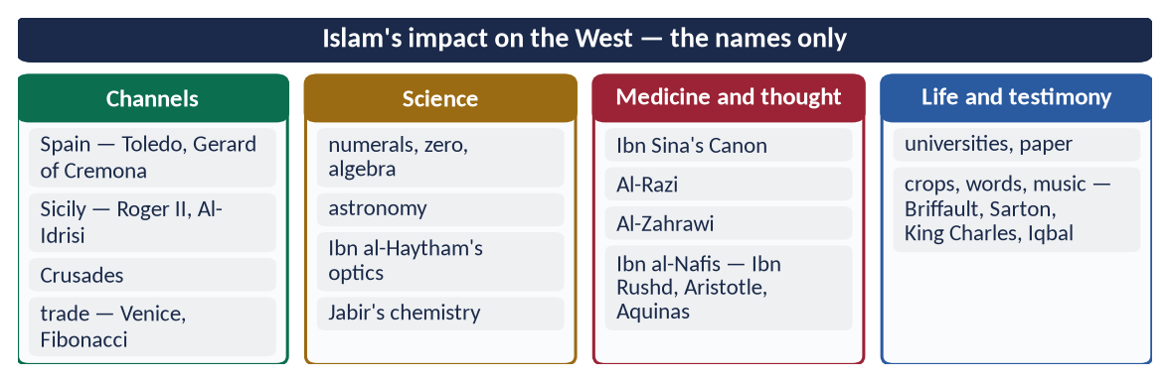
Figure 3 · At a glance — islam's impact on the West — the names only. The detail is in the sections above.
EXAMINER'S EYE · IF THIS IS ASKED
Build it as: (1) background and the Quranic command to learn; (2) channels (with the figure); (3) fields — science, medicine, philosophy, education, daily life (the table); (4) Western testimony; (5) conclusion — Muslims were teachers then, learners now; the lesson for revival.

Chapter 2 · The Impact of the West on the Muslim World
Asked in 2026: 'Explain how Western civilization has influenced Islamic civilization. Discuss the measures to protect Muslim societies from the negative impacts of Western culture.'

2.1 How the relationship reversed
The Muslims who once taught Europe fell behind it after the 16th century. Europe's Renaissance, Scientific Revolution, Industrial Revolution and colonial expansion made the West the dominant civilization, and the Muslim world came under its political, economic and cultural influence.
✦ QURAN
﴿إِن يَمۡسَسۡكُمۡ قَرۡحٞ فَقَدۡ مَسَّ ٱلۡقَوۡمَ قَرۡحٞ مِّثۡلُهُۥۚ وَتِلۡكَ ٱلۡأَيَّامُ نُدَاوِلُهَا بَيۡنَ ٱلنَّاسِ وَلِيَعۡلَمَ ٱللَّهُ ٱلَّذِينَ ءَامَنُواْ وَيَتَّخِذَ مِنكُمۡ شُهَدَآءَۗ وَٱللَّهُ لَا يُحِبُّ ٱلظَّـٰلِمِينَ﴾
“If a wound should touch you - there has already touched the [opposing] people a wound similar to it. And these days [of varying conditions] We alternate among the people so that Allah may make evident those who believe and [may] take to Himself from among you martyrs - and Allah does not like the wrongdoers.” (Aal-e-Imran, Quran)
➜ 'These days (of fortune) We alternate among the people' — power passes between nations according to their conduct.

✦ QURAN
﴿… إِنَّ ٱللَّهَ لَا يُغَيِّرُ مَا بِقَوۡمٍ حَتَّىٰ يُغَيِّرُواْ مَا بِأَنفُسِهِمۡۗ …﴾
“Indeed, Allah will not change the condition of a people until they change what is in themselves.” (Ar-Ra'd, Quran)
➜ Allah does not change the condition of a people until they change what is in themselves.

2.2 The phases of Western influence
Phase | Period | Key events
Colonial conquest | 1757–1920 | Plassey (1757); Napoleon in Egypt (1798); France in Algeria (1830); end of the Mughals (1857); Britain in Egypt (1882)
Collapse of the Ottoman order | 1914–1924 | Sykes–Picot (1916); Balfour Declaration (1917); abolition of the Caliphate (1924)
Post-colonial states | 1945–1990 | Independence of most Muslim states; Western-style constitutions, armies, bureaucracies; Cold War alliances
Globalisation and the digital age | 1990 onwards | Global markets, IMF and World Bank programmes, satellite TV, internet, social media

2.3 The positive influences

(1) Modern science and technology
Medicine, engineering, electricity, transport, communication and computing came to the Muslim world largely through the West.

(2) Modern education
Universities, laboratories and new disciplines. Sir Syed Ahmad Khan founded the Muhammadan Anglo-Oriental College, Aligarh (1875) to combine modern learning with Muslim identity.

(3) Political and administrative systems
Constitutions, parliaments, written law codes, a rule-based civil service, and the idea of fundamental rights.

(4) Awareness and reform
Printing, newspapers and contact with new ideas awakened Muslim thinkers — Jamal al-Din al-Afghani, Muhammad Abduh, Sir Syed, Allama Iqbal — to call for reform and revival.

(5) Social change
Wider education for women, public health, and awareness of human rights.
✦ QURAN
﴿ٱلَّذِينَ يَسۡتَمِعُونَ ٱلۡقَوۡلَ فَيَتَّبِعُونَ أَحۡسَنَهُۥٓۚ أُوْلَـٰٓئِكَ ٱلَّذِينَ هَدَىٰهُمُ ٱللَّهُۖ وَأُوْلَـٰٓئِكَ هُمۡ أُوْلُواْ ٱلۡأَلۡبَٰبِ﴾
“Who listen to speech and follow the best of it. Those are the ones Allah has guided, and those are people of understanding.” (Az-Zumar, Quran)
➜ 'Those who listen to speech and follow the best of it — those are the ones Allah has guided.'

2.4 The negative influences

(1) Political
- Colonial exploitation and artificial borders that still cause conflict (the Middle East after Sykes–Picot; Kashmir after 1947).
- Dependence — military, economic and technological — on Western powers after independence.

(2) Economic
- An interest-based economy and heavy debt to international lenders.
- Consumerism and imitation of Western lifestyles beyond people's means.
✦ QURAN
﴿… وَأَحَلَّ ٱللَّهُ ٱلۡبَيۡعَ وَحَرَّمَ ٱلرِّبَوٰاْۚ …﴾
“Allah has permitted trade and forbidden riba (interest).” (Al-Baqarah, Quran)
➜ 'Allah has permitted trade and forbidden riba.'

(3) Ideological
- Secularism — separating religion from public life.
- Materialism — measuring success only by wealth and comfort.
- Moral relativism — no fixed right or wrong.

(4) Cultural and social
- Individualism and weakening of the family; permissiveness in media and fashion.
- Inferiority complex — admiration of everything Western and contempt for one's own heritage.
- Language — English as the language of the elite; neglect of Urdu and regional languages (Article 251 of Pakistan's Constitution makes Urdu the national language).

(5) Intellectual
- Orientalism — Western scholarship that often portrayed Islam as backward.
✦ SCHOLARLY VIEW
Edward Said · Orientalism (1978)
Said showed that much Western writing about the East created a stereotype of the 'Oriental' as irrational and backward, which served colonial power.
➜ The critique of Orientalism.

- Dual education — modern schools without religion and madrasas without modern sciences, producing two classes who cannot understand each other.
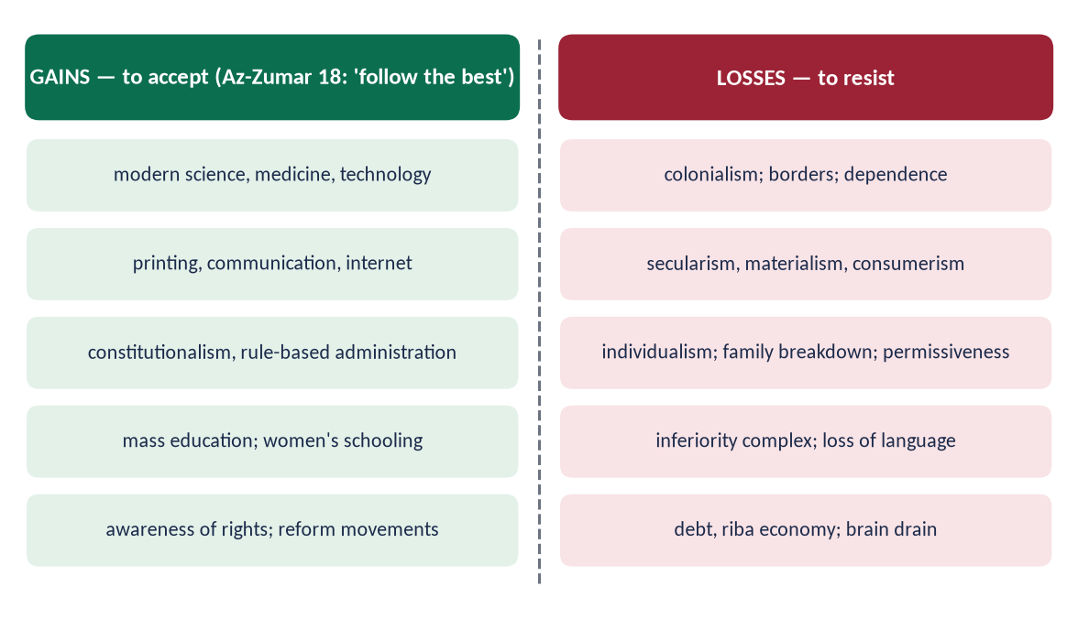
Figure 4 · The influence of the West: gains to accept and losses to resist.

2.4a The Muslim responses in history
Response | Date | What it did
Deoband (Dar al-Ulum) | 1866 | Preserved religious learning and identity after 1857
Aligarh (M.A.O. College) | 1875 | Modern Western education for Muslims with loyalty to Islam
Nadwat al-Ulama, Lucknow | 1894 | A bridge: religious learning with modern subjects and languages
Anjuman-e-Himayat-e-Islam, Lahore | 1884 | Schools and colleges for Muslim boys and girls; Iqbal recited poems at its gatherings
Al-Azhar reforms (Muhammad Abduh) | 1890s | Modern subjects and methods in the oldest Muslim university

Each was a different answer to the same Western challenge — together they preserved faith and opened the door to modern knowledge.

2.4b Western influence in Pakistan today — the visible signs
- Education: English-medium elite schools with foreign curricula beside under-funded government schools and madrasas — three tracks producing three mindsets.
- Media: foreign content dominates the screens of the young; tens of millions of Pakistanis use social media daily.
- Lifestyle: fast food, brand culture, lavish weddings borrowed from films, Western fashion as a status symbol.
- Language: English as the language of power; weak command of Urdu and Arabic among the educated elite.
- Economy: dependence on IMF programmes; an interest-based banking system (though Islamic banking now holds about a fifth of the sector's assets).
- Values: growing individualism, delayed marriage, weaker respect for elders — and, on the positive side, greater awareness of rights, girls' education and merit.

2.4c Globalisation — the newest face of Western influence
Globalisation — the free movement of goods, money, information and people across borders — spreads a single consumer culture led by Western corporations and media.
- Opportunities: trade, remittances (Pakistan received over 30 billion dollars in 2023–24), access to knowledge, global Muslim networks, the spread of Islamic finance and halal markets.
- Threats: cultural uniformity; loss of local industries; dependence on foreign technology platforms; values shaped by algorithms.
- Islamic response: participate with identity — 'know one another' (Al-Hujurat 13) — trade honestly, protect the weak, and use global media to present Islam.

2.5 The measures to protect Muslim societies

(1) The principle — selective acceptance
✦ HADITH
الْكَلِمَةُ الْحِكْمَةُ ضَالَّةُ الْمُؤْمِنِ، فَحَيْثُ وَجَدَهَا فَهُوَ أَحَقُّ بِهَا
“A word of wisdom is the lost property of the believer; wherever he finds it, he has the best right to it.” (Al-Tirmidhi)
➜ Take science and good systems from anywhere — the report is widely quoted, though its chain is weak; its meaning agrees with Az-Zumar 18.

✦ SCHOLARLY VIEW
Allama Muhammad Iqbal · Preface to The Reconstruction of Religious Thought in Islam
Iqbal wrote that the only course open to Muslims is to approach modern knowledge with a respectful but independent attitude, and to appreciate the teachings of Islam in its light, even though this may lead to differences with earlier thinkers.
➜ Respectful but independent — the model attitude.

(2) Education
- Integrate Islamic and modern education — end the two-track system.
- Teach Islamic history and civilization so that youth know their heritage.
- Promote critical thinking — to judge ideas, not copy them.

(3) The family
Strengthen marriage, parenting and the elderly's place at home — the family is the first defence of culture (Topic 4).

(4) Media and the digital space
- Produce attractive content in Urdu and regional languages rooted in Islamic values.
- Regulate harmful content (PEMRA; PECA 2016) without suppressing free speech.
- Digital literacy for parents and children.

(5) Language and identity
Promote Urdu and regional languages in education and administration (Article 251); Arabic for understanding the Quran.

(6) Economic independence
- Move towards a riba-free economy (the Federal Shariat Court's 2022 judgment; target 1 January 2028 under the 26th Amendment).
- Reduce debt; promote local industry and trade among Muslim countries.

(7) Science and technology
Invest in research, universities and innovation — to be producers, not only consumers, of technology.

(8) Role of scholars and leaders
Ulema who understand the modern world; leaders who live by Islamic values; mosques as centres of guidance for youth.

(9) Cooperation among Muslim states
OIC and ICESCO programmes for culture, education and media.
✦ QURAN
﴿وَلۡتَكُن مِّنكُمۡ أُمَّةٞ يَدۡعُونَ إِلَى ٱلۡخَيۡرِ وَيَأۡمُرُونَ بِٱلۡمَعۡرُوفِ وَيَنۡهَوۡنَ عَنِ ٱلۡمُنكَرِۚ وَأُوْلَـٰٓئِكَ هُمُ ٱلۡمُفۡلِحُونَ﴾
“And let there be [arising] from you a nation inviting to [all that is] good, enjoining what is right and forbidding what is wrong, and those will be the successful.” (Aal-e-Imran, Quran)
➜ 'Let there be among you a group inviting to good, enjoining right and forbidding wrong' — organised effort to protect society.

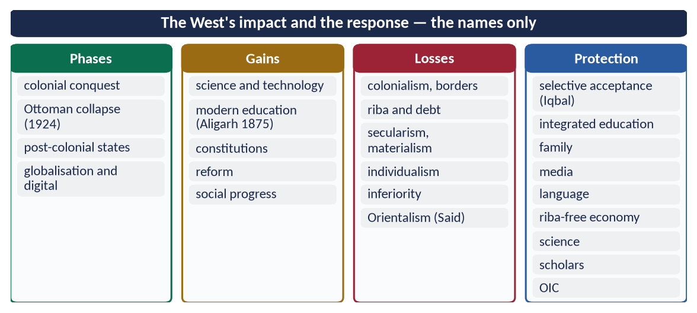
Figure 5 · At a glance — the West's impact and the response — the names only. The detail is in the sections above.

Chapter 3 · Muslim Views of Western Civilization
Asked in 2025: 'What views are found in today's Muslim circles about Western Civilization? Identify and analyze them.'

3.1 Why Muslims disagree about the West
The West is at once the source of modern science and freedoms and the former coloniser and present bearer of secular, permissive values. Muslims therefore respond to it in several ways.
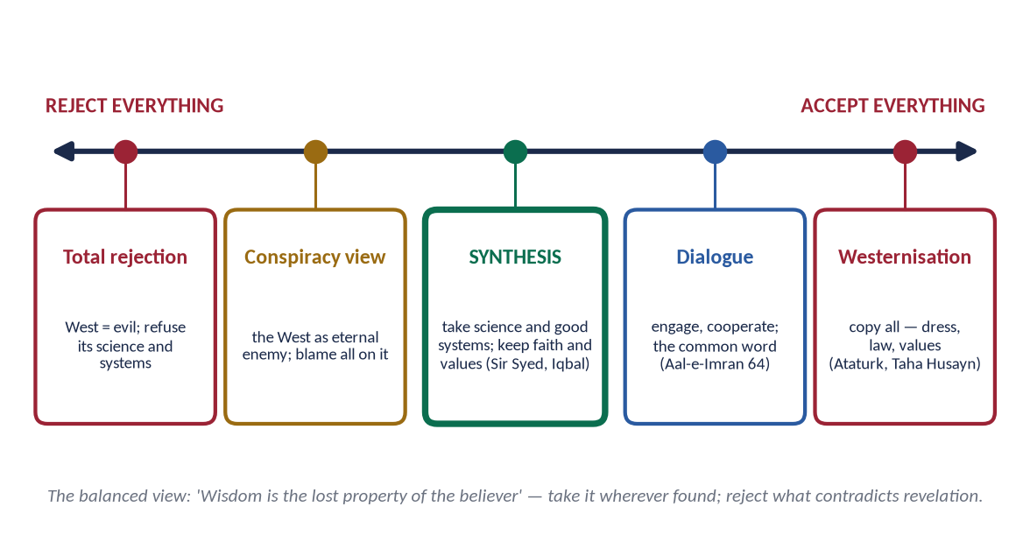
Figure 6 · Muslim views of Western civilization — from rejection to imitation, with synthesis at the centre.

3.2 View 1 — Total rejection (the defensive-traditional view)

(1) The view
Western civilization is corrupt and hostile; Muslims must reject its education, systems and culture, and return to the past.

(2) Its roots
The shock of colonialism; after 1857 some Muslims refused English education and government service; today, some voices reject all Western ideas, including democracy and science education for women.

(3) Analysis
- Strength: protects identity and values; rightly exposes Western moral problems.
- Weakness: isolates Muslims from science and progress; contradicts 'follow the best' (Az-Zumar 18) and the Muslim tradition of learning from Greece, Persia and India. It left Indian Muslims behind the Hindus in education in the 19th century — the problem Sir Syed set out to solve.

3.3 View 2 — Total acceptance (the Westernising view)

(1) The view
Muslims can progress only by copying the West completely — its law, dress, values and secular state.

(2) Its advocates
- Mustafa Kemal Atatürk — abolished the Caliphate (1924), replaced the Arabic script with the Latin (1928), banned the fez, and imposed secularism in Turkey.
- Taha Husayn (Egypt) — in The Future of Culture in Egypt (1938) argued that Egypt should follow Europe's path in civilization.

(3) Analysis
- Strength: openness to science, education and modern administration.
- Weakness: loss of identity; a split between an elite and the believing masses; imitation did not bring equal power or progress. Iqbal warned against borrowing only the outer glitter of Europe.

3.4 View 3 — Synthesis (the reformist view)

(1) The view
Take from the West its science, technology and good systems; keep Islam's beliefs, values and law; reinterpret Islamic principles through ijtihad.

(2) Its advocates
- Sir Syed Ahmad Khan — Aligarh (1875): modern education with Muslim identity.
- Jamal al-Din al-Afghani and Muhammad Abduh — revival through reason and unity.
- Allama Iqbal — 'a respectful but independent attitude' to modern knowledge; The Reconstruction of Religious Thought in Islam (1930).
✦ SCHOLARLY VIEW
Allama Muhammad Iqbal · Bal-e-Jibril
'Khira na kar saka mujhe jalwa-e-danish-e-farang / Surma hai meri aankh ka khak-e-Madina-o-Najaf' — the glitter of Western learning could not dazzle me, for the dust of Madinah and Najaf is the collyrium of my eyes.
➜ Learning from the West without being blinded by it.

(3) Analysis
- Strength: balanced; faithful to the Islamic tradition of learning; practical for development.
- Weakness: the line between 'science' and 'values' is not always easy to draw; needs strong scholars and institutions.

3.5 View 4 — Critical engagement (the civilizational critique)

(1) The view
The West must be studied deeply and criticised on its own ground — its materialism, environmental destruction and spiritual emptiness — while Islam offers an alternative civilization.

(2) Its advocates
- Muhammad Asad (Leopold Weiss, an Austrian convert and later a Pakistani diplomat) — Islam at the Crossroads (1934): Muslims should take Western science but not imitate its culture.
- Seyyed Hossein Nasr — Man and Nature (1968): the modern environmental crisis comes from a science cut off from the sacred.
- Iqbal in his poetry on the materialism of Europe.

(3) Analysis
- Strength: intellectual depth; offers Islam as a positive alternative.
- Weakness: can remain theoretical unless joined to practical reform.

3.6 View 5 — Dialogue and co-existence

(1) The view
Islam and the West share much (monotheistic roots, human dignity, justice); they should cooperate against common problems — poverty, war, climate change — and resolve differences through dialogue.

(2) Examples
The Amman Message (2004); A Common Word Between Us and You (2007), signed by 138 Muslim scholars, based on love of God and neighbour; the Document on Human Fraternity (Abu Dhabi, 2019).
✦ QURAN
﴿قُلۡ يَـٰٓأَهۡلَ ٱلۡكِتَٰبِ تَعَالَوۡاْ إِلَىٰ كَلِمَةٖ سَوَآءِۭ بَيۡنَنَا وَبَيۡنَكُمۡ أَلَّا نَعۡبُدَ إِلَّا ٱللَّهَ وَلَا نُشۡرِكَ بِهِۦ شَيۡـٔٗا وَلَا يَتَّخِذَ بَعۡضُنَا بَعۡضًا أَرۡبَابٗا مِّن دُونِ ٱللَّهِۚ …﴾
“Say: O People of the Scripture, come to a word common between us and you: that we worship none but Allah, associate nothing with Him, and that none of us take others as lords besides Allah.” (Aal-e-Imran, Quran)
➜ 'Come to a word common between us and you.'

(3) Analysis
- Strength: reduces conflict and Islamophobia; Quranic in method.
- Weakness: can be ignored by those in power; dialogue without justice (Palestine, Kashmir) loses credibility.

3.7 View 6 — The conspiracy view

(1) The view
Every Muslim problem is caused by a Western conspiracy.

(2) Analysis
- Partial truth: colonialism, wars and double standards are real.
- Weakness: it breeds passivity and blames others for our own failures — against Ar-Ra'd 11 ('until they change what is in themselves').

3.8 The comparative analysis
View | Advocates | Strength | Weakness
Rejection | Post-1857 conservatives; some today | Protects identity | Backwardness; isolation
Westernisation | Atatürk; Taha Husayn | Openness to science | Loss of identity; elite–mass split
Synthesis | Sir Syed; Afghani; Abduh; Iqbal | Balanced; practical | Hard line between science and values
Critical engagement | Muhammad Asad; S. H. Nasr | Depth; an alternative | Can stay theoretical
Dialogue | Amman Message; A Common Word | Peace; understanding | Ignored without justice
Conspiracy | Popular opinion | Sees real injustice | Passivity; blame-shifting

3.8a The views in Pakistan today
In Pakistani society all six views can be heard: a small Westernised elite that looks down on religion; conservative voices that reject almost everything Western; a large middle class that wants Western education and technology with Islamic values (synthesis); and a strong conspiracy discourse in popular media. The Constitution itself reflects the synthesis — a parliamentary democracy and fundamental rights (Western forms) under the sovereignty of Allah and Article 227 (Islamic content).

3.9 The balanced Islamic position
✦ QURAN
﴿وَكَذَٰلِكَ جَعَلۡنَٰكُمۡ أُمَّةٗ وَسَطٗا لِّتَكُونُواْ شُهَدَآءَ عَلَى ٱلنَّاسِ وَيَكُونَ ٱلرَّسُولُ عَلَيۡكُمۡ شَهِيدٗاۗ …﴾
“And thus We have made you a middle (just) nation, that you may be witnesses over mankind and the Messenger a witness over you.” (Al-Baqarah, Quran)
➜ 'We have made you a middle nation' — neither blind rejection nor blind imitation.

Take the science, technology, administration and rights that are good; reject secularism, materialism, permissiveness and riba; engage in dialogue; and, above all, reform ourselves so that Muslims once again contribute to world civilization.
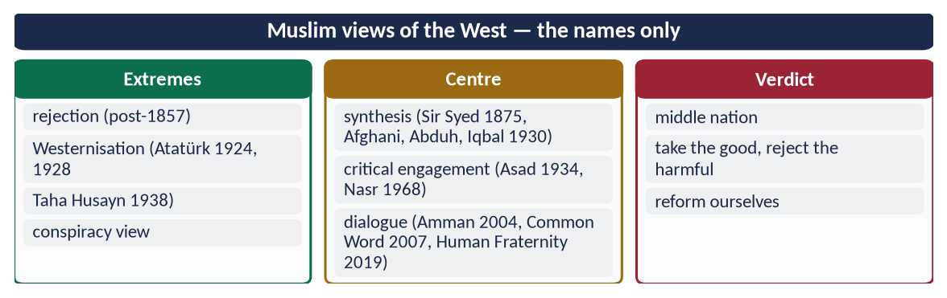
Figure 7 · At a glance — muslim views of the West — the names only. The detail is in the sections above.

Chapter 4 · Islamic Ideology and Modern Western Thought: Individuality
Asked in 2015: 'Give a comparison of Islamic ideology and modern Western thought about present trends of individuality.'

4.1 Individuality and individualism — the terms
- Individuality — the distinct personality, dignity and responsibility of each person.
- Individualism — a philosophy that makes the individual the centre and measure of all value, placing personal freedom and self-interest above family, community and religion.
Islam affirms individuality; it rejects extreme individualism.

4.2 The rise of Western individualism
Stage | Period | Idea
Renaissance humanism | 14th–16th c. | Man, not God, at the centre of culture
Reformation | 16th c. | The individual's own conscience and reading of scripture
Enlightenment and liberalism | 17th–18th c. | Reason and natural rights; John Locke: life, liberty, property
J. S. Mill, *On Liberty* | 1859 | The 'harm principle': a person may do anything that does not harm others
Existentialism | 20th c. | Sartre: 'existence precedes essence' — man creates his own meaning
Consumer and digital individualism | Late 20th–21st c. | Identity through choice, consumption and self-display

4.3 The present trends of individuality in the West
- (a) Autonomy above all — 'my body, my life, my choice'.
- (b) Rights without duties — claims on society, few obligations to it.
- (c) Secularism — religion a private opinion, not a public guide.
- (d) Moral relativism — no universal right or wrong; each defines his own values.
- (e) Weakening of the family — fewer marriages, more single-person households, the elderly in care homes.
- (f) Loneliness — the United Kingdom appointed a Minister for Loneliness in 2018; Japan did the same in 2021.
- (g) Consumerism and self-display — identity through brands and social media.
- (h) Redefinition of identity — gender and family redefined by individual choice.

4.4 The Islamic view of the individual

(1) Dignity of each person
✦ QURAN
﴿وَلَقَدۡ كَرَّمۡنَا بَنِيٓ ءَادَمَ وَحَمَلۡنَٰهُمۡ فِي ٱلۡبَرِّ وَٱلۡبَحۡرِ وَرَزَقۡنَٰهُم مِّنَ ٱلطَّيِّبَٰتِ وَفَضَّلۡنَٰهُمۡ عَلَىٰ كَثِيرٖ مِّمَّنۡ خَلَقۡنَا تَفۡضِيلٗا﴾
“And We have certainly honored the children of Adam and carried them on the land and sea and provided for them of the good things and preferred them over much of what We have created, with [definite] preference.” (Al-Isra, Quran)
➜ 'We have honoured the children of Adam.'

(2) Individual responsibility
✦ QURAN
﴿كُلُّ نَفۡسِۭ بِمَا كَسَبَتۡ رَهِينَةٌ﴾
“Every soul, for what it has earned, will be retained.” (Al-Muddaththir, Quran)
➜ 'Every soul is held in pledge for what it has earned.'

✦ QURAN
﴿… وَلَا تَزِرُ وَازِرَةٞ وِزۡرَ أُخۡرَىٰۚ …﴾
“No bearer of burdens shall bear the burden of another.” (Al-An'am, Quran)
➜ 'No bearer of burdens shall bear the burden of another.'

✦ QURAN
﴿وَكُلُّهُمۡ ءَاتِيهِ يَوۡمَ ٱلۡقِيَٰمَةِ فَرۡدًا﴾
“And all of them are coming to Him on the Day of Resurrection alone.” (Maryam, Quran)
➜ 'Every one of them will come to Him on the Day of Resurrection alone.'

(3) The individual as a trustee, not an owner
Life, body, wealth and time are trusts (amanah) from Allah. A person may not destroy himself:
✦ QURAN
﴿… لَا تَأۡكُلُوٓاْ أَمۡوَٰلَكُم بَيۡنَكُم بِٱلۡبَٰطِلِ إِلَّآ أَن تَكُونَ تِجَٰرَةً عَن تَرَاضٖ مِّنكُمۡۚ …﴾
“Do not consume one another's wealth unjustly, but only in lawful trade by mutual consent.” (An-Nisa, Quran)
➜ 'Do not kill yourselves; Allah is ever Merciful to you' — even the body is not one's absolute property.

(4) Freedom within limits
Free will and choice (Al-Kahf 29: 'whoever wills, let him believe…'), but within the limits of Allah (hudud Allah) and without harming others.

(5) The individual within the community
✦ HADITH
يَدُ اللَّهِ مَعَ الْجَمَاعَةِ
“The hand of Allah is with the community.” (Al-Tirmidhi)
➜ The individual flourishes within the jama'ah.

✦ HADITH
مَثَلُ الْمُؤْمِنِينَ فِي تَوَادِّهِمْ وَتَرَاحُمِهِمْ وَتَعَاطُفِهِمْ مَثَلُ الْجَسَدِ، إِذَا اشْتَكَى مِنْهُ عُضْوٌ تَدَاعَى لَهُ سَائِرُ الْجَسَدِ بِالسَّهَرِ وَالْحُمَّى
“The believers, in their love, mercy and kindness to one another, are like one body: when one limb suffers, the whole body responds with sleeplessness and fever.” (Muslim)
➜ One body, not separate atoms.

(6) Rights joined with duties
Every right of one person is the duty of another — parents and children, husband and wife, ruler and ruled.

(7) Worship that joins the individual to the group
Congregational prayer, Zakat, the fast of Ramadan together, Hajj — each develops the individual through the community.

4.5 Iqbal: Khudi and Bekhudi
✦ SCHOLARLY VIEW
Allama Muhammad Iqbal · Asrar-e-Khudi (1915) and Rumuz-e-Bekhudi (1918)
In Asrar-e-Khudi (The Secrets of the Self), Iqbal taught that each individual must develop his khudi — selfhood — through faith, love and action. In Rumuz-e-Bekhudi (The Mysteries of Selflessness), he taught that the self reaches its fulfilment only within the Millat — the community bound by Tawhid and the Prophet ﷺ.
➜ The Islamic balance: strong individuals, united community.

'Fard qaim rabt-e-millat se hai, tanha kuch nahin / Mauj hai darya mein aur bairun-e-darya kuch nahin' — the individual lives through his bond with the nation; alone he is nothing; the wave exists in the river, outside it is nothing.

4.6 The comparison
Point | Modern Western thought | Islamic ideology
Centre of value | The individual self | Allah; the individual as His servant and vicegerent
Source of values | Personal choice, reason, majority | Revelation, confirmed by reason and fitrah
Freedom | Maximum, limited only by harm to others | Real, but within the limits of Allah and the good of society
Ownership of self | 'My body, my choice' | Body and life are a trust (amanah)
Rights and duties | Rights emphasised | Rights and duties together
Family | A private choice among lifestyles | A sacred institution and a duty
Community | Voluntary association | The Ummah — 'one body'
Accountability | To law and conscience | To law, conscience and Allah in the Hereafter
Result | Freedom and creativity; but loneliness, family decline, relativism | Dignity with belonging; responsibility with freedom

4.7 What Islam appreciates in Western individuality
Respect for personal dignity, freedom of conscience, rule of law, protection of privacy and encouragement of personal initiative — all of which Islam also teaches (Al-Isra 70; Al-Baqarah 256; An-Nur 27).

4.7a The consequences of extreme individualism — what the evidence shows
Area | Consequence
Family | Fewer and later marriages; high divorce; many children raised by one parent
Old age | The elderly alone or in care homes; 'loneliness epidemic' declared by the US Surgeon General (2023)
Mental health | Rising anxiety and depression among the young, linked with social media comparison
Community | Decline of neighbourhood and voluntary ties ('Bowling Alone', Robert Putnam, 2000)
Morality | Relativism — no shared standards of right and wrong
Economy | Consumer debt; identity built on possessions

The Quran describes the man who makes his desire his god:
✦ QURAN
﴿أَفَرَءَيۡتَ مَنِ ٱتَّخَذَ إِلَٰهَهُۥ هَوَىٰهُ وَأَضَلَّهُ ٱللَّهُ عَلَىٰ عِلۡمٖ وَخَتَمَ عَلَىٰ سَمۡعِهِۦ وَقَلۡبِهِۦ وَجَعَلَ عَلَىٰ بَصَرِهِۦ غِشَٰوَةٗ فَمَن يَهۡدِيهِ مِنۢ بَعۡدِ ٱللَّهِۚ أَفَلَا تَذَكَّرُونَ﴾
“Have you seen he who has taken as his god his [own] desire, and Allah has sent him astray due to knowledge and has set a seal upon his hearing and his heart and put over his vision a veil? So who will guide him after Allah? Then will you not be reminded.” (Al-Jathiyah, Quran)
➜ 'Have you seen the one who takes his own desire as his god?' — the root of extreme individualism.

4.8 The present trend among Muslims
Globalisation and social media are spreading individualism among Muslim youth: less time for family, more self-centred choices, weakening of respect for elders. The Islamic answer is not to crush individuality but to root it in faith and community — Iqbal's balance of khudi and bekhudi.
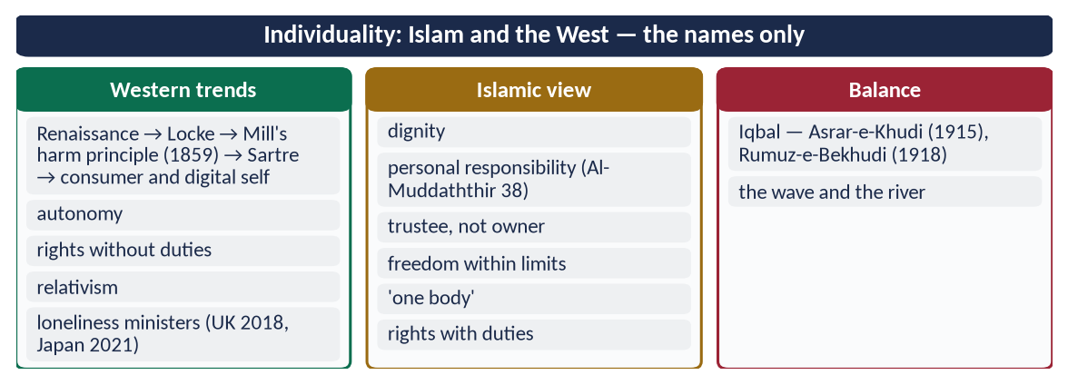
Figure 8 · At a glance — individuality: Islam and the West — the names only. The detail is in the sections above.

Chapter 5 · The Role of Islam in the Modern World
Named in the syllabus — never asked directly, likely to come.

5.1 The problems of modern man
Problem | Evidence
Spiritual emptiness and mental illness | Depression affects about 280 million people worldwide (WHO); rising suicide and addiction
Breakdown of the family | High divorce rates; loneliness of the elderly; children without stable homes
Extreme inequality | Oxfam (2024): the richest 1 percent own more wealth than the bottom 95 percent of humanity
Debt and financial crises | Interest-based crises — 2008 global financial crisis; debt traps of poor countries
Environmental crisis | Climate change, pollution, loss of species; Pakistan's 2022 floods affected about 33 million people
Racism and xenophobia | Hatred of migrants and minorities; Islamophobia
War and weapons | Nuclear arms; wars that kill civilians
Moral relativism | No agreed right or wrong; the market and the majority decide
Technology without ethics | Artificial intelligence, surveillance, misinformation

✦ QURAN
﴿ظَهَرَ ٱلۡفَسَادُ فِي ٱلۡبَرِّ وَٱلۡبَحۡرِ بِمَا كَسَبَتۡ أَيۡدِي ٱلنَّاسِ لِيُذِيقَهُم بَعۡضَ ٱلَّذِي عَمِلُواْ لَعَلَّهُمۡ يَرۡجِعُونَ﴾
“Corruption has appeared throughout the land and sea by [reason of] what the hands of people have earned so He may let them taste part of [the consequence of] what they have done that perhaps they will return [to righteousness].” (Ar-Rum, Quran)
➜ 'Corruption has appeared on land and sea because of what the hands of people have earned' — the Quran's diagnosis of the modern crisis.

✦ QURAN
﴿وَمَنۡ أَعۡرَضَ عَن ذِكۡرِي فَإِنَّ لَهُۥ مَعِيشَةٗ ضَنكٗا وَنَحۡشُرُهُۥ يَوۡمَ ٱلۡقِيَٰمَةِ أَعۡمَىٰ﴾
“And whoever turns away from My remembrance - indeed, he will have a depressed life, and We will gather him on the Day of Resurrection blind.” (Taha, Quran)
➜ 'Whoever turns away from My remembrance — for him is a life of hardship.'

5.2 Islam's answers

(1) Meaning and peace — the spiritual answer
✦ QURAN
﴿ٱلَّذِينَ ءَامَنُواْ وَتَطۡمَئِنُّ قُلُوبُهُم بِذِكۡرِ ٱللَّهِۗ أَلَا بِذِكۡرِ ٱللَّهِ تَطۡمَئِنُّ ٱلۡقُلُوبُ﴾
“Those who have believed and whose hearts are assured by the remembrance of Allah. Unquestionably, by the remembrance of Allah hearts are assured.” (Ar-Ra'd, Quran)
➜ 'In the remembrance of Allah hearts find rest.'

Tawhid gives life a purpose (Adh-Dhariyat 56) and a moral compass; prayer, fasting and dhikr heal the restless soul.

(2) A stable family
Marriage as Sunnah, love and mercy (Ar-Rum 21), rights of spouses, parents and children (Topic 4).

(3) Economic justice
- Zakat — a guaranteed share of the poor in the wealth of the rich (At-Tawbah 60).
- Prohibition of riba — finance tied to real trade and shared risk.
✦ QURAN
﴿… وَأَحَلَّ ٱللَّهُ ٱلۡبَيۡعَ وَحَرَّمَ ٱلرِّبَوٰاْۚ …﴾
“Allah has permitted trade and forbidden riba (interest).” (Al-Baqarah, Quran)
➜ 'Allah has permitted trade and forbidden riba.'

- Circulation of wealth — Al-Hashr 7; inheritance spreads wealth over generations.
- Islamic finance today manages over 3 trillion dollars of assets worldwide (IFSB) — a working alternative.

(4) Care of the environment
✦ QURAN
﴿وَٱلسَّمَآءَ رَفَعَهَا وَوَضَعَ ٱلۡمِيزَانَ ۝ أَلَّا تَطۡغَوۡاْ فِي ٱلۡمِيزَانِ ۝ وَأَقِيمُواْ ٱلۡوَزۡنَ بِٱلۡقِسۡطِ وَلَا تُخۡسِرُواْ ٱلۡمِيزَانَ﴾
“And the heaven He raised and imposed the balance. That you not transgress within the balance. And establish weight in justice and do not make deficient the balance.” (Ar-Rahman, Quran)
➜ He set up the balance (mizan): do not transgress the balance; weigh with justice and do not fall short.

✦ QURAN
﴿… وَكُلُواْ وَٱشۡرَبُواْ وَلَا تُسۡرِفُوٓاْۚ إِنَّهُۥ لَا يُحِبُّ ٱلۡمُسۡرِفِينَ﴾
“And eat and drink, but do not be excessive; indeed, He does not like those who are excessive.” (Al-A'raf, Quran)
➜ 'Eat and drink, but do not waste.'

✦ HADITH
إِنْ قَامَتِ السَّاعَةُ وَفِي يَدِ أَحَدِكُمْ فَسِيلَةٌ، فَإِنِ اسْتَطَاعَ أَنْ لَا يَقُومَ حَتَّى يَغْرِسَهَا فَلْيَغْرِسْهَا
“If the Hour comes while one of you has a sapling in his hand, let him plant it if he can.” (Musnad Ahmad)
➜ Planting as worship — until the last moment.

Man is the khalifah, a trustee of the earth, not its owner.

(5) Equality against racism
Al-Hujurat 13 and the Farewell Sermon — 'no Arab over a non-Arab, no white over black'.

(6) Peace and the ethics of war
No killing of civilians; 'incline to peace' (Al-Anfal 61) — Topic 3.

(7) Moral absolutes with flexibility
Fixed principles (justice, truth, chastity) with ijtihad for new situations — the answer to relativism.

(8) Knowledge with ethics
Science as worship and trust — the answer to technology without conscience (AI, weapons).

5.2a Islam and the modern ideologies
Ideology | Its claim | The Islamic answer
Capitalism | Private property and free markets bring prosperity | Accepts property and markets, but adds Zakat, bans riba, hoarding and monopoly, and ties wealth to duty (Al-Hashr 7)
Socialism / Communism | State ownership ends exploitation | Rejects abolition of property and religion; ends exploitation by justice, Zakat and inheritance instead
Secularism | Religion is private; the state is neutral | Religion guides the whole of life, including law and government, while protecting others' freedom (Al-Baqarah 256)
Liberalism | Maximum individual freedom | Freedom with responsibility, within the limits of Allah (Chapter 4)
Nationalism | The nation is the highest loyalty | Love of one's land is natural, but the highest loyalty is to Allah and justice; the Ummah above race (Al-Hujurat 13)
Materialism | Only matter and pleasure are real | The unseen, the soul and the Hereafter give life meaning (Al-Baqarah 3)

✦ SCHOLARLY VIEW
Allama Muhammad Iqbal · Javid Nama; Zarb-e-Kalim
Iqbal criticised both capitalism and communism: the first worships wealth, the second denies God; Islam alone joins social justice with faith.
➜ The third way.

5.2b Islam's appeal in the modern world — the evidence
- Islam is among the fastest-growing religions in the world (Pew Research projections).
- Many Western converts cite Tawhid, the Quran's rationality, prayer and the family as their reasons.
- Islamic finance proved relatively stable in the 2008 crisis and is now offered by banks in London, Kuala Lumpur and Dubai.
- Ramadan fasting and intermittent fasting have drawn medical interest; halal has become a global quality market.

5.2c Islam, science and technology today
The Quran never set religion against science: it calls on people to observe (Al-Ghashiyah 17–20: 'do they not look at the camels, how they are created…'), to travel and study (Al-Ankabut 20), and to use reason (the repeated afala ta'qilun — 'will you not reason?'). The tension between science and religion was a European experience (the Galileo affair, 1633), not a Muslim one. Today's task is to restore that harmony: research as worship, ethics in technology, and Muslim contributions to medicine, climate science and artificial intelligence.
✦ QURAN
﴿أَفَلَا يَنظُرُونَ إِلَى ٱلۡإِبِلِ كَيۡفَ خُلِقَتۡ ۝ وَإِلَى ٱلسَّمَآءِ كَيۡفَ رُفِعَتۡ ۝ وَإِلَى ٱلۡجِبَالِ كَيۡفَ نُصِبَتۡ ۝ وَإِلَى ٱلۡأَرۡضِ كَيۡفَ سُطِحَتۡ﴾
“Then do they not look at the camels - how they are created. And at the sky - how it is raised. And at the mountains - how they are erected. And at the earth - how it is spread out.” (Al-Ghashiyah, Quran)
➜ 'Do they not look at the camels, how they are created; at the sky, how it is raised; at the mountains, how they are set; at the earth, how it is spread?'

5.3 The Muslim world's role — the middle nation
✦ QURAN
﴿وَكَذَٰلِكَ جَعَلۡنَٰكُمۡ أُمَّةٗ وَسَطٗا لِّتَكُونُواْ شُهَدَآءَ عَلَى ٱلنَّاسِ وَيَكُونَ ٱلرَّسُولُ عَلَيۡكُمۡ شَهِيدٗاۗ …﴾
“And thus We have made you a middle (just) nation, that you may be witnesses over mankind and the Messenger a witness over you.” (Al-Baqarah, Quran)
➜ 'We have made you a middle nation, so that you may be witnesses over mankind.'

✦ QURAN
﴿كُنتُمۡ خَيۡرَ أُمَّةٍ أُخۡرِجَتۡ لِلنَّاسِ تَأۡمُرُونَ بِٱلۡمَعۡرُوفِ وَتَنۡهَوۡنَ عَنِ ٱلۡمُنكَرِ وَتُؤۡمِنُونَ بِٱللَّهِۗ …﴾
“You are the best nation brought forth for mankind: you enjoin what is right, forbid what is wrong, and believe in Allah.” (Aal-e-Imran, Quran)
➜ 'You are the best nation brought forth for mankind: you enjoin right, forbid wrong and believe in Allah.'

The role of Islam will be seen in the world only when Muslims show it in practice — just governance, honest economies, strong families, knowledge and service to humanity.
✦ SCHOLARLY VIEW
Allama Muhammad Iqbal · The Reconstruction of Religious Thought in Islam, Lecture VI
Iqbal wrote that humanity today needs three things: a spiritual interpretation of the universe, the spiritual emancipation of the individual, and basic principles of a universal import directing the evolution of human society on a spiritual basis — and that Islam offers them.
➜ The three needs Islam meets.

✦ SCHOLARLY VIEW
George Bernard Shaw · The Genuine Islam (1936)
Shaw predicted that the faith of Muhammad would be acceptable to the Europe of tomorrow, and that a man like him would solve the problems of the modern world.
➜ A Western prediction.

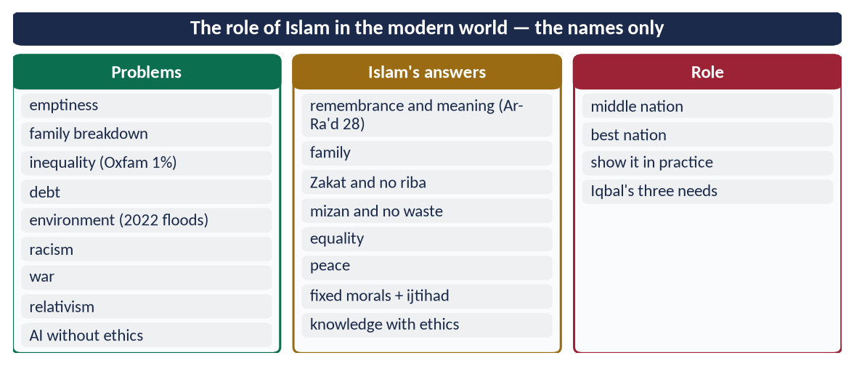
Figure 9 · At a glance — the role of Islam in the modern world — the names only. The detail is in the sections above.

Chapter 6 · The Muslim Ummah: Concept, Structure and Revival
Asked in 2015: 'Explain the concept and structure of the Muslim Ummah and give suggestions for its revival.'

6.1 The concept of the Ummah

(1) The word
Ummah (أُمَّة) comes from umm — mother, origin, purpose. An ummah is a community bound together by a common purpose and faith, not by race, language or territory.

(2) One Ummah under one Lord
✦ QURAN
﴿إِنَّ هَٰذِهِۦٓ أُمَّتُكُمۡ أُمَّةٗ وَٰحِدَةٗ وَأَنَا۠ رَبُّكُمۡ فَٱعۡبُدُونِ﴾
“Indeed this, your religion, is one religion, and I am your Lord, so worship Me.” (Al-Anbiya, Quran)
➜ 'Indeed, this Ummah of yours is one Ummah, and I am your Lord, so worship Me.'

✦ QURAN
﴿وَإِنَّ هَٰذِهِۦٓ أُمَّتُكُمۡ أُمَّةٗ وَٰحِدَةٗ وَأَنَا۠ رَبُّكُمۡ فَٱتَّقُونِ﴾
“And indeed this, your religion, is one religion, and I am your Lord, so fear Me.” (Al-Mu'minun, Quran)
➜ This Ummah of yours is one Ummah, and I am your Lord, so fear Me.

(3) Its qualities
✦ QURAN
﴿وَكَذَٰلِكَ جَعَلۡنَٰكُمۡ أُمَّةٗ وَسَطٗا لِّتَكُونُواْ شُهَدَآءَ عَلَى ٱلنَّاسِ وَيَكُونَ ٱلرَّسُولُ عَلَيۡكُمۡ شَهِيدٗاۗ …﴾
“And thus We have made you a middle (just) nation, that you may be witnesses over mankind and the Messenger a witness over you.” (Al-Baqarah, Quran)
➜ A middle nation (ummatan wasatan) — balanced, just, a witness over mankind.

✦ QURAN
﴿كُنتُمۡ خَيۡرَ أُمَّةٍ أُخۡرِجَتۡ لِلنَّاسِ تَأۡمُرُونَ بِٱلۡمَعۡرُوفِ وَتَنۡهَوۡنَ عَنِ ٱلۡمُنكَرِ وَتُؤۡمِنُونَ بِٱللَّهِۗ …﴾
“You are the best nation brought forth for mankind: you enjoin what is right, forbid what is wrong, and believe in Allah.” (Aal-e-Imran, Quran)
➜ The best nation (khayra ummah) raised for mankind — because it enjoins good, forbids evil and believes in Allah.

(4) Brotherhood — the bond
✦ QURAN
﴿إِنَّمَا ٱلۡمُؤۡمِنُونَ إِخۡوَةٞ فَأَصۡلِحُواْ بَيۡنَ أَخَوَيۡكُمۡۚ وَٱتَّقُواْ ٱللَّهَ لَعَلَّكُمۡ تُرۡحَمُونَ﴾
“The believers are but brothers, so make settlement between your brothers. And fear Allah that you may receive mercy.” (Al-Hujurat, Quran)
➜ 'The believers are but brothers.'

✦ HADITH
الْمُسْلِمُ أَخُو الْمُسْلِمِ، لَا يَظْلِمُهُ وَلَا يُسْلِمُهُ
“A Muslim is the brother of a Muslim: he does not wrong him, nor does he abandon him (to his enemy).” (Al-Bukhari and Muslim)
➜ Brotherhood means protection.

✦ HADITH
مَثَلُ الْمُؤْمِنِينَ فِي تَوَادِّهِمْ وَتَرَاحُمِهِمْ وَتَعَاطُفِهِمْ مَثَلُ الْجَسَدِ، إِذَا اشْتَكَى مِنْهُ عُضْوٌ تَدَاعَى لَهُ سَائِرُ الْجَسَدِ بِالسَّهَرِ وَالْحُمَّى
“The believers are like one body: when one limb suffers, the whole body responds with sleeplessness and fever.” (Muslim)
➜ The argument for solidarity with Palestine, Kashmir and every suffering Muslim people.

(5) The Ummah is not racial nationalism
✦ SCHOLARLY VIEW
Allama Muhammad Iqbal · Bang-e-Dra; Rumuz-e-Bekhudi
Iqbal rejected territorial and racial nationalism as the 'idol' of the age — 'In taza khudaon mein bara sab se watan hai' — and taught that the Muslim nation is bound by faith: 'Apni millat par qiyas aqwam-e-maghrib se na kar / Khas hai tarkib mein qaum-e-Rasool-e-Hashmi' — do not judge your nation by the nations of the West; the nation of the Prophet ﷺ is unique in its composition.
➜ The Ummah is ideological, not racial.

6.2 The structure of the Ummah
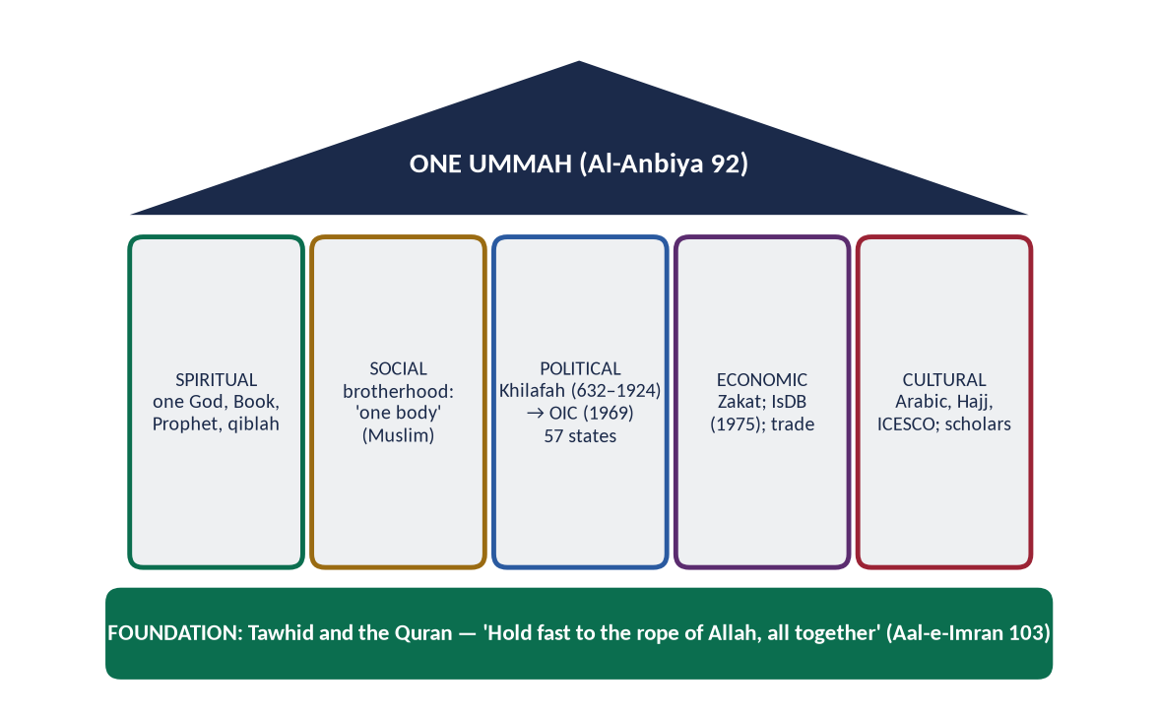
Figure 10 · The structure of the Ummah: a foundation, five pillars and one roof.

(1) The spiritual structure
One God, one Book, one Prophet ﷺ, one qiblah; the five pillars performed together across the world; the Hajj as the annual assembly of the Ummah.

(2) The social structure
Brotherhood, mutual rights, mosques as community centres, the family as the basic cell.

(3) The political structure
- The Khilafah — from 632 (Abu Bakr) to its abolition in 1924: the political unity of the Ummah under the Rashidun, Umayyads, Abbasids and Ottomans (with parallel states).
- Today: 57 sovereign states, cooperating through the Organisation of Islamic Cooperation (OIC) — founded in Rabat, 1969, after the arson attack on Al-Aqsa; charter 1972; renamed in 2011; headquarters Jeddah. Pakistan hosted the second OIC summit in Lahore (1974).

(4) The economic structure
Zakat and waqf within societies; the Islamic Development Bank (1975) and OIC trade arrangements between states.

(5) The cultural and educational structure
Arabic as the language of worship; Hajj; universities like Al-Azhar; ICESCO (Islamic World Educational, Scientific and Cultural Organization).

6.3 The history — rise and decline

(1) Rise
From Madinah in 622, the Ummah spread within a century from Spain to Sindh; for about eight centuries it led the world in science and culture.

(2) The causes of decline
Cause | Explanation
Disunity and sectarianism | Civil wars; rival dynasties; sectarian hatred
Loss of ijtihad | 'Closing of the gate of ijtihad'; rigid taqlid (Iqbal, Lecture VI)
Neglect of science | After the 13th century, science declined in madrasas
Despotism | Hereditary kingship replaced shura; rulers above accountability
Moral decay and luxury | Ibn Khaldun's cycle
External blows | The Mongols (Baghdad, 1258); the Reconquista (1492); colonialism
Economic stagnation | Trade routes shifted to the Atlantic

✦ QURAN
﴿وَأَطِيعُواْ ٱللَّهَ وَرَسُولَهُۥ وَلَا تَنَٰزَعُواْ فَتَفۡشَلُواْ وَتَذۡهَبَ رِيحُكُمۡۖ وَٱصۡبِرُوٓاْۚ إِنَّ ٱللَّهَ مَعَ ٱلصَّـٰبِرِينَ﴾
“And obey Allah and His Messenger, and do not dispute and [thus] lose courage and [then] your strength would depart; and be patient. Indeed, Allah is with the patient.” (Al-Anfal, Quran)
➜ 'Do not dispute, lest you lose courage and your strength departs' — the Quranic cause of decline.

6.3a The movements for Muslim unity
- Jamal al-Din al-Afghani (d. 1897) — called on Muslims everywhere to unite against colonialism and reform through reason (pan-Islamism).
- The Khilafat Movement (India, 1919–1924) — led by the Ali brothers (Maulana Muhammad Ali Jauhar and Maulana Shaukat Ali) to save the Ottoman Caliphate; it united Indian Muslims politically and trained a generation of leaders.
- The Motamar al-Alam al-Islami (1926) and the Muslim World League (Rabitat al-Alam al-Islami, 1962, Makkah).
- The OIC (1969) — the first inter-state organisation of the Muslim world.

6.3b The OIC — achievements and failures
Achievements | Failures
Common platform of 57 states; voice at the UN | Non-binding decisions; little enforcement
Islamic Development Bank (1975); ICESCO; COMSTECH | Intra-OIC trade still only about a fifth of members' trade
The Islamophobia resolution (UNGA 76/254, 2022) | Unable to stop wars between or within members (Iran–Iraq, Syria, Yemen)
Support for Palestine and Kashmir in resolutions | Little practical effect on occupation in Palestine and Kashmir
Contact group on the Rohingya; the ICJ case (2019) | Rivalries between leading members weaken collective action

6.3c Iqbal's vision of the Ummah
Iqbal hoped that Muslim nations would first become strong and independent, and then form a 'League of Muslim Nations' — a family of free Muslim states cooperating on the basis of Islam (Reconstruction, Lecture VI). The OIC is a partial fulfilment of this vision; its full realisation needs unity, strength and justice within each member.

6.4 Suggestions for the revival of the Ummah

(1) Return to the Quran and Sunnah — with ijtihad
✦ QURAN
﴿وَٱعۡتَصِمُواْ بِحَبۡلِ ٱللَّهِ جَمِيعٗا وَلَا تَفَرَّقُواْۚ وَٱذۡكُرُواْ نِعۡمَتَ ٱللَّهِ عَلَيۡكُمۡ إِذۡ كُنتُمۡ أَعۡدَآءٗ فَأَلَّفَ بَيۡنَ قُلُوبِكُمۡ فَأَصۡبَحۡتُم بِنِعۡمَتِهِۦٓ إِخۡوَٰنٗا …﴾
“And hold firmly to the rope of Allah all together and do not become divided. Remember Allah's favour upon you: you were enemies, and He brought your hearts together, and by His favour you became brothers.” (Aal-e-Imran, Quran)
➜ 'Hold fast to the rope of Allah all together and do not be divided.'

✦ SCHOLARLY VIEW
Allama Muhammad Iqbal · The Reconstruction of Religious Thought in Islam, Lecture VI
Iqbal called ijtihad 'the principle of movement in the structure of Islam' and urged that it be exercised collectively through a Muslim legislative assembly.
➜ Revival through ijtihad, not imitation.

(2) Unity above sect and nation
Respect for all schools of law; an end to sectarian hatred (Al-An'am 159); cooperation above national rivalries.

(3) Knowledge, science and technology
✦ QURAN
﴿… يَرۡفَعِ ٱللَّهُ ٱلَّذِينَ ءَامَنُواْ مِنكُمۡ وَٱلَّذِينَ أُوتُواْ ٱلۡعِلۡمَ دَرَجَٰتٖۚ …﴾
“Allah will raise those who have believed among you and those who were given knowledge, by degrees.” (Al-Mujadilah, Quran)
➜ Allah raises those who believe and those given knowledge by degrees.

Many Muslim countries spend well under 1 percent of GDP on research; universities must be rebuilt as centres of discovery.

(4) Good governance and justice
✦ QURAN
﴿وَٱلَّذِينَ ٱسۡتَجَابُواْ لِرَبِّهِمۡ وَأَقَامُواْ ٱلصَّلَوٰةَ وَأَمۡرُهُمۡ شُورَىٰ بَيۡنَهُمۡ وَمِمَّا رَزَقۡنَٰهُمۡ يُنفِقُونَ﴾
“And those who have responded to their lord and established prayer and whose affair is [determined by] consultation among themselves, and from what We have provided them, they spend.” (Ash-Shura, Quran)
➜ Their affairs are by consultation among themselves.

Accountable governments, rule of law, and the end of corruption (Topic 8).

(5) Economic integration
- Increase intra-OIC trade (around one-fifth of members' total trade).
- An Islamic common market; the use of Islamic finance; joint investment through the IsDB.

(6) Defence and security cooperation
✦ QURAN
﴿وَأَعِدُّواْ لَهُم مَّا ٱسۡتَطَعۡتُم مِّن قُوَّةٖ وَمِن رِّبَاطِ ٱلۡخَيۡلِ تُرۡهِبُونَ بِهِۦ عَدُوَّ ٱللَّهِ وَعَدُوَّكُمۡ …﴾
“Prepare against them whatever you are able of power and of steeds of war, by which you may deter the enemy of Allah and your enemy.” (Al-Anfal, Quran)
➜ 'Prepare whatever strength you can.'

Joint defence production and coordination; the Islamic Military Counter-Terrorism Coalition (2015) is one step.

(7) A reformed OIC
Binding decisions, a dispute-settlement mechanism, a stronger role on Palestine and Kashmir, and an OIC voice in the UN.

(8) Media and the youth
A strong Muslim media voice in world languages; investment in youth education and skills.

(9) Moral and spiritual renewal
✦ QURAN
﴿… إِنَّ ٱللَّهَ لَا يُغَيِّرُ مَا بِقَوۡمٍ حَتَّىٰ يُغَيِّرُواْ مَا بِأَنفُسِهِمۡۗ …﴾
“Indeed, Allah will not change the condition of a people until they change what is in themselves.” (Ar-Ra'd, Quran)
➜ Allah does not change a people until they change what is in themselves.

✦ SCHOLARLY VIEW
Allama Muhammad Iqbal · Bang-e-Dra
'Aik hon Muslim Haram ki pasbani ke liye / Neel ke sahil se le kar tabak-e-khak-e-Kashghar' — let the Muslims unite to guard the Haram, from the banks of the Nile to the soil of Kashghar.
➜ The poet of Muslim unity.

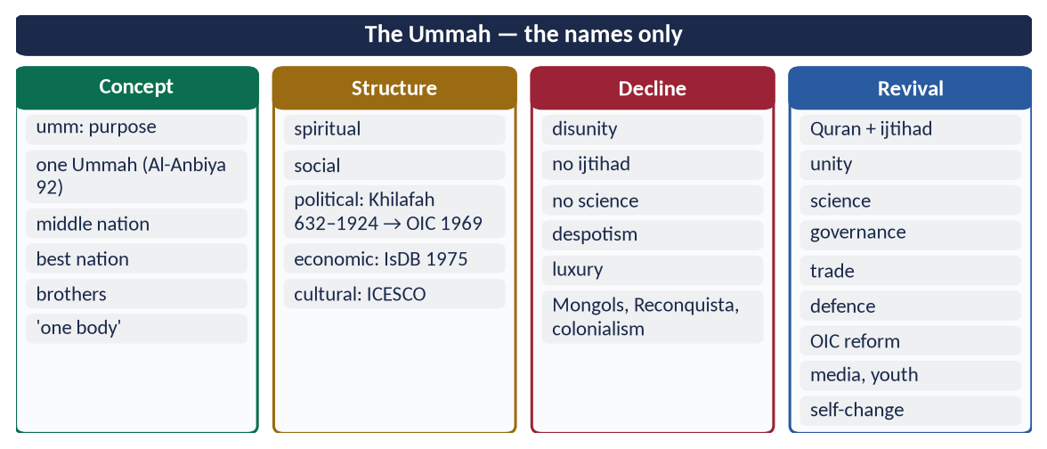
Figure 11 · At a glance — the Ummah — the names only. The detail is in the sections above.

Chapter 7 · The Muslim World: Contemporary Challenges and Solutions
Asked in 2016: 'What are the contemporary challenges of Muslim world? Suggest its solutions in the light of Quran and Sunnah.'
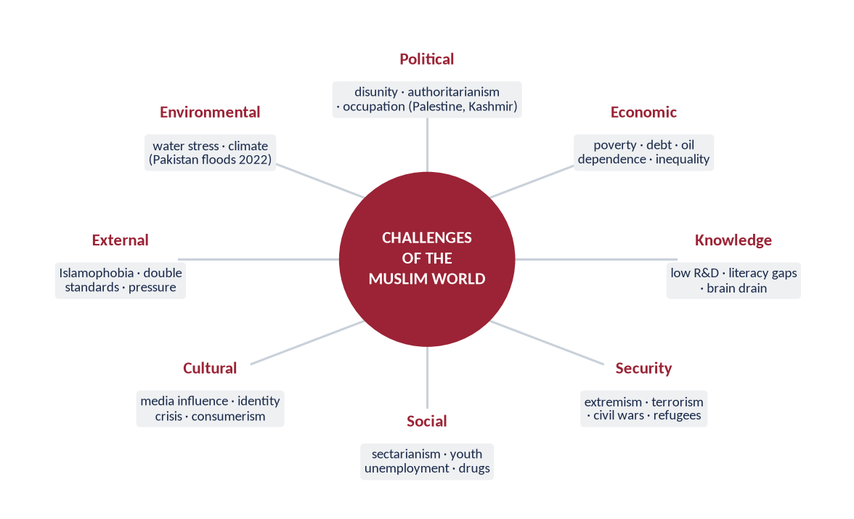
Figure 12 · The eight groups of challenges facing the Muslim world.

7.1 Political challenges
- Disunity — rivalries between Muslim states; the OIC unable to act together.
- Authoritarianism and weak institutions — little accountability; military and dynastic rule.
- Occupation and conflict — Palestine (occupation since 1967; the war in Gaza since October 2023, with more than 60,000 Palestinians killed by mid-2025 according to Gaza's health authorities); Kashmir (disputed since 1947; special status revoked by India on 5 August 2019); civil wars in Syria, Yemen, Sudan, Libya.
- Foreign intervention — Iraq (2003), Afghanistan (2001–2021).

7.2 Economic challenges
- Poverty and inequality — the OIC holds about a quarter of humanity but a much smaller share of world income.
- Debt and dependence — IMF programmes; reliance on oil or remittances.
- Unemployment — especially among the young.
- Weak intra-Muslim trade — about one-fifth of members' trade.

7.3 Educational and scientific challenges
- Low literacy in several countries (Pakistan about 60 percent); millions of children out of school.
- Low spending on research; few world-ranked universities; dependence on imported technology.
- Brain drain — skilled graduates leaving (over 800,000 Pakistanis went abroad for work in 2023 alone, according to the Bureau of Emigration).

7.4 Security challenges
- Extremism and terrorism — killing Muslims more than anyone else (Topic 7).
- Refugees — millions displaced from Syria, Afghanistan, Sudan and Myanmar (the Rohingya, over 700,000 of whom fled in 2017).

7.5 Social challenges
- Sectarianism — Sunni–Shia and intra-Sunni conflict (2026 question under Topic 7).
- Youth bulge — a young population without jobs or direction.
- Drug abuse, family breakdown, corruption.

7.6 Cultural and ideological challenges
- Western cultural influence through media and technology; identity crisis among youth.
- Materialism and consumerism.
- The gap between religion and modern education.

7.7 External challenges
- Islamophobia in the West and in India (Chapter 9).
- Double standards in international law — Palestine and Kashmir versus Ukraine.

7.8 Environmental challenges
Water scarcity in the Middle East and South Asia; climate change — Pakistan, contributing under 1 percent of global emissions, suffered the 2022 floods that affected about 33 million people.

7.8a Pakistan's role in the Muslim world
- Founding and leading member of the OIC; host of the second OIC summit (Lahore, 1974) and of OIC foreign ministers' meetings.
- The only Muslim nuclear power — a responsibility for peace and deterrence (Al-Anfal 60).
- Tabled the Islamophobia resolution at the UN on behalf of the OIC (2022).
- Hosted millions of Afghan refugees for over four decades — among the largest refugee populations in the world.
- UN peacekeeping — one of the largest contributors of troops.
- Mediator — Pakistan has tried to mediate between Muslim states.
The Quran's description fits the role Pakistan should play:
✦ QURAN
﴿وَإِن طَآئِفَتَانِ مِنَ ٱلۡمُؤۡمِنِينَ ٱقۡتَتَلُواْ فَأَصۡلِحُواْ بَيۡنَهُمَاۖ …﴾
“And if two groups of the believers fight, then make peace between them.” (Al-Hujurat, Quran)
➜ If two groups of believers fight, make peace between them — and act justly.

7.8b Case note — Palestine
- 1917 — the Balfour Declaration promised a 'national home for the Jewish people' in Palestine.
- 1948 — creation of Israel; about 700,000 Palestinians expelled or fled (the Nakba).
- 1967 — Israel occupied the West Bank, East Jerusalem and Gaza; UNSC Resolution 242 called for withdrawal.
- 1969 — the arson at Al-Aqsa led to the founding of the OIC.
- 1993 — the Oslo Accords; the promised Palestinian state never came.
- October 2023 onwards — the war in Gaza; more than 60,000 killed by mid-2025 (Gaza health authorities); the ICJ provisional measures (January 2024) and advisory opinion (July 2024).
- Pakistan's position: an independent, viable Palestinian state on the pre-1967 borders with Al-Quds al-Sharif as its capital; Pakistan does not recognise Israel.
✦ QURAN
﴿سُبۡحَٰنَ ٱلَّذِيٓ أَسۡرَىٰ بِعَبۡدِهِۦ لَيۡلٗا مِّنَ ٱلۡمَسۡجِدِ ٱلۡحَرَامِ إِلَى ٱلۡمَسۡجِدِ ٱلۡأَقۡصَا ٱلَّذِي بَٰرَكۡنَا حَوۡلَهُۥ لِنُرِيَهُۥ مِنۡ ءَايَٰتِنَآۚ إِنَّهُۥ هُوَ ٱلسَّمِيعُ ٱلۡبَصِيرُ﴾
“Exalted is He who took His Servant by night from al-Masjid al-Haram to al-Masjid al-Aqsa, whose surroundings We have blessed, to show him of Our signs. Indeed, He is the Hearing, the Seeing.” (Al-Isra, Quran)
➜ Glory be to Him who took His servant by night from the Sacred Mosque to Al-Masjid al-Aqsa, whose surroundings We have blessed — the religious bond of every Muslim with Al-Aqsa.

7.9 Solutions in the light of the Quran and Sunnah
Challenge | Quran / Sunnah | Practical step
Disunity | Aal-e-Imran 103: hold fast together; 'one body' (Muslim) | Reformed OIC; mediation between Muslim states
Bad governance | Ash-Shura 38: consultation; An-Nisa 58: trusts and justice | Accountable democracy; rule of law
Poverty | At-Tawbah 60: Zakat; Al-Hashr 7: circulation | Zakat systems; Islamic finance; IsDB
Ignorance | Al-Alaq 1: Read!; Al-Mujadilah 11: raised by knowledge | Research funding; OIC science programme (COMSTECH)
Weakness | Al-Anfal 60: prepare strength | Defence cooperation; self-reliance
Extremism | Al-Baqarah 143: middle nation; Al-Ma'idah 32 | Counter-narratives (Paigham-e-Pakistan); education
Sectarianism | Al-An'am 159; Al-Hujurat 10 | Respect for all schools; joint platforms of ulema
Occupation | Al-Hajj 39: right of the oppressed; An-Nisa 75 | Diplomacy; UN resolutions; ICJ; humanitarian aid
Cultural invasion | Az-Zumar 18: follow the best | Quality media; integrated education
Environment | Ar-Rahman 7–9: the balance; 'plant the sapling' (Ahmad) | Climate diplomacy; water management

✦ QURAN
﴿… إِنَّ ٱللَّهَ لَا يُغَيِّرُ مَا بِقَوۡمٍ حَتَّىٰ يُغَيِّرُواْ مَا بِأَنفُسِهِمۡۗ …﴾
“Indeed, Allah will not change the condition of a people until they change what is in themselves.” (Ar-Ra'd, Quran)
➜ Allah does not change the condition of a people until they change what is in themselves — every solution begins with self-reform.

✦ HADITH
الْمُؤْمِنُ لِلْمُؤْمِنِ كَالْبُنْيَانِ يَشُدُّ بَعْضُهُ بَعْضًا
“The believer to the believer is like a building whose parts support one another.” (Al-Bukhari and Muslim)
➜ Solidarity as structure, not sentiment.

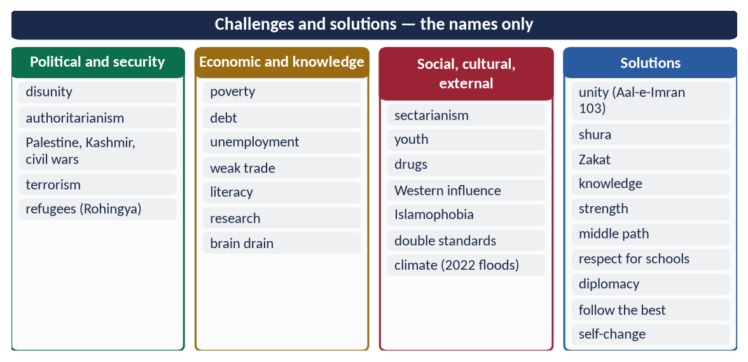
Figure 13 · At a glance — challenges and solutions — the names only. The detail is in the sections above.

Chapter 8 · Co-existence in a Multi-faith Society
Asked in 2021: 'Comment on the teachings of Islam regarding co-existence in a multi-faith society.'

8.1 The meaning
Co-existence — ta'ayush (تَعَايُش) — means people of different faiths living together in peace, justice and mutual respect, each free to practise his religion, cooperating in the common good. It does not mean mixing religions (syncretism) or giving up one's beliefs.

8.2 The Quranic principles of co-existence

(1) Diversity is Allah's will
✦ QURAN
﴿وَأَنزَلۡنَآ إِلَيۡكَ ٱلۡكِتَٰبَ بِٱلۡحَقِّ مُصَدِّقٗا لِّمَا بَيۡنَ يَدَيۡهِ مِنَ ٱلۡكِتَٰبِ وَمُهَيۡمِنًا عَلَيۡهِۖ …﴾
“And We have revealed to you the Book in truth, confirming the Scripture that came before it and as a criterion (muhaymin) over it.” (Al-Ma'idah, Quran)
➜ Had Allah willed, He would have made you one community; but He tests you in what He has given you — so compete in good deeds.

✦ QURAN
﴿وَلَوۡ شَآءَ رَبُّكَ لَأٓمَنَ مَن فِي ٱلۡأَرۡضِ كُلُّهُمۡ جَمِيعًاۚ أَفَأَنتَ تُكۡرِهُ ٱلنَّاسَ حَتَّىٰ يَكُونُواْ مُؤۡمِنِينَ﴾
“And had your Lord willed, those on earth would have believed - all of them entirely. Then, [O Muhammad], would you compel the people in order that they become believers.” (Yunus, Quran)
➜ Had your Lord willed, all on earth would have believed; would you then compel people until they become believers?

(2) No compulsion
✦ QURAN
﴿لَآ إِكۡرَاهَ فِي ٱلدِّينِۖ قَد تَّبَيَّنَ ٱلرُّشۡدُ مِنَ ٱلۡغَيِّۚ …﴾
“There is no compulsion in religion; the right course has become clear from the wrong.” (Al-Baqarah, Quran)
➜ No compulsion in religion.

(3) Freedom of belief with clarity of identity
✦ QURAN
﴿لَكُمۡ دِينُكُمۡ وَلِيَ دِينِ﴾
“For you is your religion, and for me is my religion.” (Al-Kafirun, Quran)
➜ 'For you your religion, and for me mine.'

(4) Kindness and justice to peaceful non-Muslims
✦ QURAN
﴿لَّا يَنۡهَىٰكُمُ ٱللَّهُ عَنِ ٱلَّذِينَ لَمۡ يُقَٰتِلُوكُمۡ فِي ٱلدِّينِ وَلَمۡ يُخۡرِجُوكُم مِّن دِيَٰرِكُمۡ أَن تَبَرُّوهُمۡ وَتُقۡسِطُوٓاْ إِلَيۡهِمۡۚ إِنَّ ٱللَّهَ يُحِبُّ ٱلۡمُقۡسِطِينَ﴾
“Allah does not forbid you from those who do not fight you because of religion and do not expel you from your homes - from being righteous toward them and acting justly toward them. Indeed, Allah loves those who act justly.” (Al-Mumtahanah, Quran)
➜ Allah does not forbid kindness and justice to those who do not fight you or expel you.

(5) Respect for what others hold sacred
✦ QURAN
﴿وَلَا تَسُبُّواْ ٱلَّذِينَ يَدۡعُونَ مِن دُونِ ٱللَّهِ فَيَسُبُّواْ ٱللَّهَ عَدۡوَۢا بِغَيۡرِ عِلۡمٖۗ …﴾
“Do not insult those they invoke besides Allah, lest they insult Allah in enmity, without knowledge.” (Al-An'am, Quran)
➜ 'Do not insult those they invoke besides Allah, lest they insult Allah in ignorance.'

(6) Dialogue in the best manner
✦ QURAN
﴿وَلَا تُجَٰدِلُوٓاْ أَهۡلَ ٱلۡكِتَٰبِ إِلَّا بِٱلَّتِي هِيَ أَحۡسَنُ …﴾
“And do not argue with the People of the Scripture except in the way that is best.” (Al-Ankabut, Quran)
➜ 'Do not argue with the People of the Scripture except in the best way.'

✦ QURAN
﴿قُلۡ يَـٰٓأَهۡلَ ٱلۡكِتَٰبِ تَعَالَوۡاْ إِلَىٰ كَلِمَةٖ سَوَآءِۭ بَيۡنَنَا وَبَيۡنَكُمۡ أَلَّا نَعۡبُدَ إِلَّا ٱللَّهَ وَلَا نُشۡرِكَ بِهِۦ شَيۡـٔٗا وَلَا يَتَّخِذَ بَعۡضُنَا بَعۡضًا أَرۡبَابٗا مِّن دُونِ ٱللَّهِۚ …﴾
“Say: O People of the Scripture, come to a word common between us and you: that we worship none but Allah, associate nothing with Him, and that none of us take others as lords besides Allah.” (Aal-e-Imran, Quran)
➜ 'Come to a word common between us and you.'

(7) Protection of all places of worship
✦ QURAN
﴿… وَلَوۡلَا دَفۡعُ ٱللَّهِ ٱلنَّاسَ بَعۡضَهُم بِبَعۡضٖ لَّهُدِّمَتۡ صَوَٰمِعُ وَبِيَعٞ وَصَلَوَٰتٞ وَمَسَٰجِدُ يُذۡكَرُ فِيهَا ٱسۡمُ ٱللَّهِ كَثِيرٗاۗ …﴾
“Were it not that Allah checks some people by means of others, monasteries, churches, synagogues and mosques — in which Allah's name is much mentioned — would have been demolished.” (Al-Hajj, Quran)
➜ Were it not for Allah's check, monasteries, churches, synagogues and mosques would be destroyed.

(8) One human family
✦ QURAN
﴿يَـٰٓأَيُّهَا ٱلنَّاسُ إِنَّا خَلَقۡنَٰكُم مِّن ذَكَرٖ وَأُنثَىٰ وَجَعَلۡنَٰكُمۡ شُعُوبٗا وَقَبَآئِلَ لِتَعَارَفُوٓاْۚ إِنَّ أَكۡرَمَكُمۡ عِندَ ٱللَّهِ أَتۡقَىٰكُمۡۚ إِنَّ ٱللَّهَ عَلِيمٌ خَبِيرٞ﴾
“O mankind, indeed We have created you from male and female and made you peoples and tribes that you may know one another. Indeed, the most noble of you in the sight of Allah is the most righteous of you. Indeed, Allah is Knowing and Acquainted.” (Al-Hujurat, Quran)
➜ Nations and tribes to know one another.

8.3 The Prophetic model
- The Charter of Madinah (622) — Muslims, Jews and Arab clans as one political community: 'to the Jews their religion, to the Muslims theirs'.
- The Najran treaty — churches, clergy and property of Christians protected; they prayed in the Mosque of Madinah.
- Personal relations — he visited a sick Jewish boy, stood for a Jewish funeral ('is it not a soul?'), traded with Jews, and accepted gifts from Christian rulers.
- Muslims as a minority — in Abyssinia, Muslims lived loyally under a just Christian king — the model for Muslim minorities today.
✦ HADITH
أَلَا مَنْ ظَلَمَ مُعَاهَدًا، أَوِ انْتَقَصَهُ، أَوْ كَلَّفَهُ فَوْقَ طَاقَتِهِ، أَوْ أَخَذَ مِنْهُ شَيْئًا بِغَيْرِ طِيبِ نَفْسٍ، فَأَنَا حَجِيجُهُ يَوْمَ الْقِيَامَةِ
“Whoever wrongs a non-Muslim under covenant, belittles him, burdens him beyond his capacity or takes anything from him without his consent — I will be his advocate against him on the Day of Resurrection.” (Abu Dawud)

✦ HADITH
مَنْ قَتَلَ مُعَاهَدًا لَمْ يَرِحْ رَائِحَةَ الْجَنَّةِ
“Whoever kills a non-Muslim under covenant will not smell the fragrance of Paradise.” (Al-Bukhari)

8.4 The historical record
Umar's covenant with Jerusalem (638), Muhammad bin Qasim in Sindh (712), Cordoba, the Ottoman millets, Mughal India — see Topic 5, Chapter 10.

8.5 The rights of non-Muslims in an Islamic state
Life, property and honour; freedom of worship and places of worship; their own personal law; justice in court; welfare from the state; representation; protection from abuse.

8.6 Modern declarations
- The Amman Message (2004) — against extremism and takfir; recognition of the schools of Islam.
- A Common Word Between Us and You (2007) — 138 Muslim scholars to Christian leaders: love of God and love of neighbour.
- The Marrakesh Declaration (January 2016) — Muslim scholars affirmed the rights of religious minorities in Muslim lands, citing the Charter of Madinah.
- The Document on Human Fraternity (Abu Dhabi, February 2019) — signed by the Grand Imam of Al-Azhar and Pope Francis.

8.7 Co-existence in Pakistan
- Constitution: Article 20 (freedom to profess religion and manage religious institutions); Article 22 (safeguards in education); Article 36 (protection of minorities); reserved seats for minorities.
- The Quaid's vision — 11 August 1947: 'You are free to go to your temples … mosques or any other place of worship.'
- Minorities — about 3.6 percent of the population (Census 2023): Hindus, Christians, Sikhs and others.
- Kartarpur Corridor (November 2019) — visa-free access for Sikh pilgrims to Gurdwara Darbar Sahib.
- Paigham-e-Pakistan (2018) — scholars of all schools against violence and hatred.

Challenges
Hate speech; mob violence over allegations of blasphemy; complaints of forced conversions; discrimination in jobs and education.

Solutions
Rule of law against mobs; curriculum that teaches the Islamic ethics of co-existence; interfaith councils; equal citizenship in practice; the ulema's leadership against incitement.
TRAP · CO-EXISTENCE IS NOT SYNCRETISM
Say clearly: co-existence means peace and justice with difference, not merging beliefs. Surah Al-Kafirun both protects others' freedom ('for you your religion') and preserves Muslim identity ('for me mine').

8.8 Muslims as minorities — the principles
About a third of the world's Muslims live as minorities (India alone has about 200 million). The scholars of fiqh al-aqalliyyat (the jurisprudence of minorities) draw these principles from the Quran and the Abyssinian model:
- (a) Loyalty to lawful covenants — obey the law of the land where it does not require disobeying Allah (Al-Isra 34: fulfil commitments).
- (b) Preserve identity — prayer, family, halal food, Islamic education.
- (c) Contribute to society — honest work, charity, civic participation; 'the best of people are those most beneficial to people' (Al-Tabarani).
- (d) Seek rights through law — courts, elections, peaceful advocacy, not violence.
- (e) Invite by example — the Muslims of Abyssinia won the Negus's protection by their truthfulness.

8.9 Tools of interfaith harmony
Tool | Example
Law | Articles 20, 36; laws against hate speech and incitement
Education | Curriculum on the rights of minorities and the Charter of Madinah
Dialogue platforms | Interfaith councils; joint statements of religious leaders
Shared service | Joint relief work in floods and disasters
Religious tourism | Kartarpur; Katas Raj; Hindu and Sikh pilgrims to Pakistan
Media | Programmes that show minorities as fellow citizens

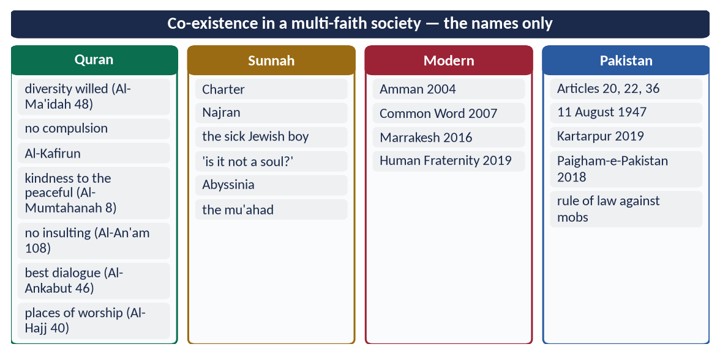
Figure 14 · At a glance — co-existence in a multi-faith society — the names only. The detail is in the sections above.

Chapter 9 · Islamophobia: Causes and Remedies
Asked in 2021: 'Islamophobia is a sign of extremism. Give suggestions for its remedy.'

9.1 The meaning
Islamophobia is irrational fear of, prejudice against, or hostility towards Islam and Muslims, leading to discrimination, exclusion and violence. The term was popularised by the Runnymede Trust report Islamophobia: A Challenge for Us All (1997, United Kingdom).

9.2 Its forms
Form | Examples
Violence | The Christchurch mosque attacks (15 March 2019, New Zealand) — 51 worshippers killed; attacks on mosques and veiled women
Insult to the sacred | Cartoons of the Prophet ﷺ (Denmark, 2005; later France); public burning of the Quran (Sweden and Denmark, 2023)
Discriminatory laws | Headscarf bans in French schools (2004) and face-veil bans (2010); minaret ban (Switzerland, 2009); India's Citizenship Amendment Act (2019)
Media and political rhetoric | Stereotyping Islam as violent; far-right campaigns against Muslim migrants
Everyday discrimination | In jobs, housing, airports and schools
Mass persecution | The Rohingya of Myanmar (2017)

9.3 The causes
- (a) Terrorism by a few Muslims — 9/11 (2001) and later attacks, exploited to blame all Muslims.
- (b) Media stereotyping — 'Islam = terror' in news and films.
- (c) Orientalism and history — centuries of hostile images since the Crusades (Edward Said).
- (d) Political exploitation — far-right and nationalist parties use fear of Muslims for votes.
- (e) The 'clash of civilizations' thesis — Samuel Huntington (Foreign Affairs, 1993; book 1996) presented Islam as the West's next enemy.
- (f) Migration and economic fear — Muslim migrants blamed for unemployment and crime.
- (g) Ignorance — little real knowledge of Islam.
- (h) Muslims' own conduct — sectarian violence, poor treatment of minorities and failure to present Islam well.

9.4 'Islamophobia is a sign of extremism'

(1) Islamophobia is itself extremism
It is an extremist ideology — judging over a billion people by the crimes of a few, calling for their exclusion, and sometimes killing them (Christchurch). The Christchurch attacker's manifesto was steeped in white-supremacist extremism.

(2) It feeds, and is fed by, Muslim extremism
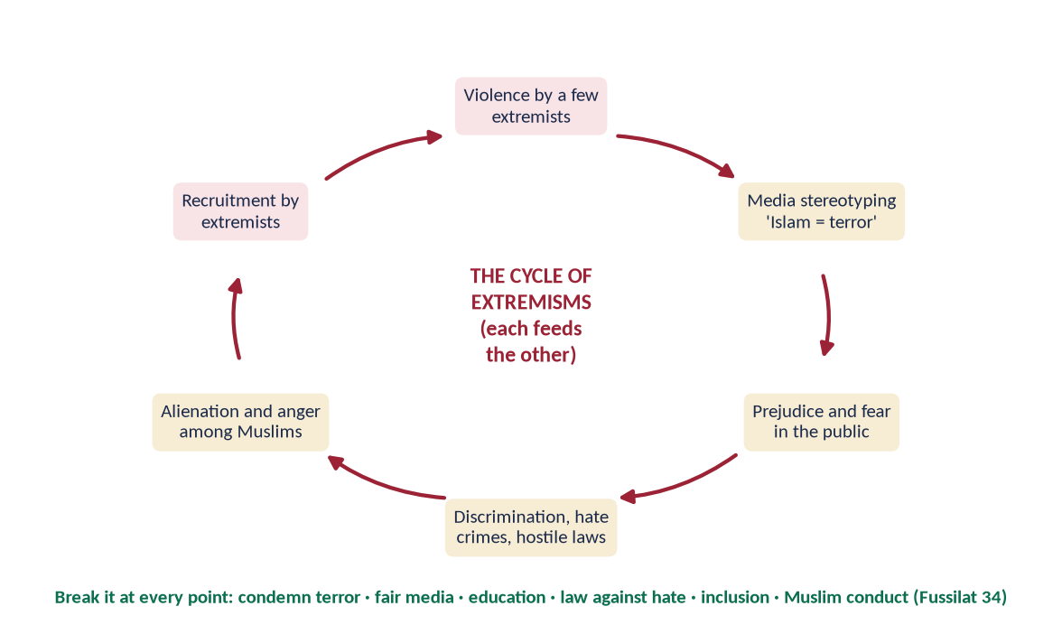
Figure 15 · The cycle of extremisms: each feeds the other.
Terrorist attacks by extremists produce fear; fear produces discrimination; discrimination produces alienation; alienation is exploited by extremist recruiters — who carry out more attacks. Both extremisms need each other.

(3) The Quranic rule — no collective guilt
✦ QURAN
﴿… وَلَا تَزِرُ وَازِرَةٞ وِزۡرَ أُخۡرَىٰۚ …﴾
“No bearer of burdens shall bear the burden of another.” (Al-An'am, Quran)
➜ 'No bearer of burdens shall bear the burden of another.'

✦ QURAN
﴿… وَلَا يَجۡرِمَنَّكُمۡ شَنَـَٔانُ قَوۡمٍ عَلَىٰٓ أَلَّا تَعۡدِلُواْۚ ٱعۡدِلُواْ هُوَ أَقۡرَبُ لِلتَّقۡوَىٰۖ …﴾
“Do not let the hatred of a people lead you to be unjust. Be just; that is nearer to righteousness.” (Al-Ma'idah, Quran)
➜ 'Do not let the hatred of a people lead you to injustice.'

9.5 The remedies

(1) International action
- UN General Assembly Resolution 76/254 (15 March 2022) — declared 15 March the International Day to Combat Islamophobia, on a resolution tabled by Pakistan on behalf of the OIC; the date marks the Christchurch attacks.
- UN General Assembly Resolution 78/264 (March 2024) — 'Measures to combat Islamophobia', calling for a UN Special Envoy on Islamophobia.
- OIC — an Islamophobia Observatory and diplomatic campaigns.

(2) Legal measures
Laws against hate speech and hate crime; protection of places of worship; international norms against insulting religious symbols.

(3) Education and dialogue
Teaching about Islam in Western schools; interfaith dialogue (A Common Word, Human Fraternity); academic exchange.

(4) Media engagement
Muslim journalists, film-makers and writers presenting the real Islam; fact-checking and challenging stereotypes.

(5) Muslims' own conduct — the most powerful remedy
✦ QURAN
﴿وَلَا تَسۡتَوِي ٱلۡحَسَنَةُ وَلَا ٱلسَّيِّئَةُۚ ٱدۡفَعۡ بِٱلَّتِي هِيَ أَحۡسَنُ فَإِذَا ٱلَّذِي بَيۡنَكَ وَبَيۡنَهُۥ عَدَٰوَةٞ كَأَنَّهُۥ وَلِيٌّ حَمِيمٞ﴾
“And not equal are the good deed and the bad. Repel [evil] by that [deed] which is better; and thereupon the one whom between you and him is enmity [will become] as though he was a devoted friend.” (Fussilat, Quran)
➜ 'Repel evil with what is better; then the one between whom and you is enmity will become as a devoted friend.'

✦ QURAN
﴿ٱدۡعُ إِلَىٰ سَبِيلِ رَبِّكَ بِٱلۡحِكۡمَةِ وَٱلۡمَوۡعِظَةِ ٱلۡحَسَنَةِۖ وَجَٰدِلۡهُم بِٱلَّتِي هِيَ أَحۡسَنُۚ …﴾
“Invite to the way of your Lord with wisdom and good instruction, and argue with them in the way that is best.” (An-Nahl, Quran)
➜ Invite with wisdom and good instruction.

- Condemn terrorism clearly and consistently.
- Protect minorities in Muslim countries (so that the demand for rights abroad is credible).
- Muslims in the West: participate positively in society, as the Muslims of Abyssinia did.

(6) Answering insults the Prophetic way
Firm love for the Prophet ﷺ expressed through lawful, collective and diplomatic protest, not violence; his own answer to insult was dignity and gentleness (Topic 3).
✦ QURAN
﴿إِنَّا كَفَيۡنَٰكَ ٱلۡمُسۡتَهۡزِءِينَ﴾
“Indeed, We are sufficient for you against the mockers.” (Al-Hijr, Quran)
➜ 'We are sufficient for you against the mockers.'

9.6 Islamophobia and the Muslim diaspora — the positive record
Muslims in the West have answered hostility with contribution: Muslim doctors served on the front line of the COVID-19 pandemic; mosques opened food banks; Muslim athletes, writers and public figures changed perceptions; after Christchurch, New Zealand's response of solidarity — the adhan broadcast nationally and women wearing headscarves in sympathy — showed that Islamophobia can be defeated by unity.
✦ HADITH
خَيْرُ النَّاسِ أَنْفَعُهُمْ لِلنَّاسِ
“The best of people are those most beneficial to people.” (Al-Tabarani)
➜ Service is the most convincing answer to hate.

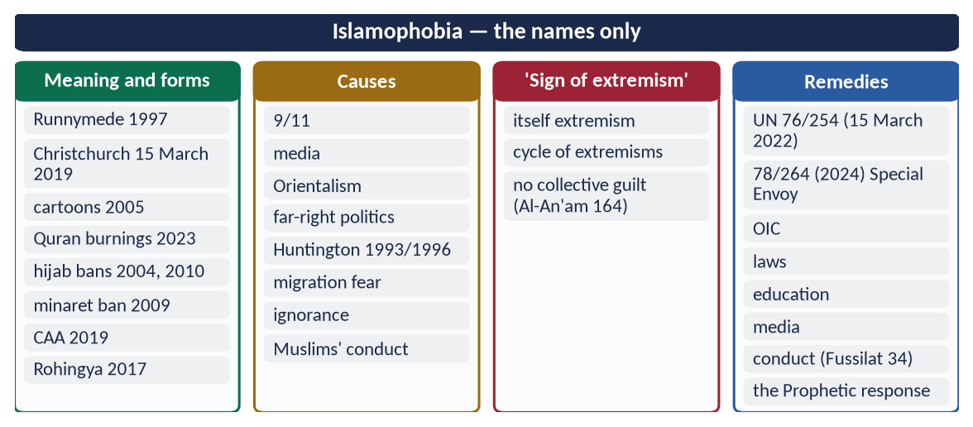
Figure 16 · At a glance — islamophobia — the names only. The detail is in the sections above.

Chapter 10 · The Two-Nation Theory and the Muslims of India and Kashmir
Asked in 2026: 'In the light of the plight of Indian and Kashmiri Muslims, discuss the justification and demands of the Two-Nation Theory.'

10.1 The Two-Nation Theory — meaning
The Two-Nation Theory — Du-Qaumi Nazariyah — holds that the Muslims and Hindus of the subcontinent were two separate nations, different in religion, culture, law, history and way of life, and that the Muslims were entitled to a separate homeland where they could live according to Islam. It was the ideological basis of Pakistan.

10.2 The Islamic basis
✦ QURAN
﴿إِنَّمَا ٱلۡمُؤۡمِنُونَ إِخۡوَةٞ فَأَصۡلِحُواْ بَيۡنَ أَخَوَيۡكُمۡۚ وَٱتَّقُواْ ٱللَّهَ لَعَلَّكُمۡ تُرۡحَمُونَ﴾
“The believers are but brothers, so make settlement between your brothers. And fear Allah that you may receive mercy.” (Al-Hujurat, Quran)
➜ 'The believers are but brothers' — Muslim nationhood rests on faith.

✦ QURAN
﴿إِنَّ هَٰذِهِۦٓ أُمَّتُكُمۡ أُمَّةٗ وَٰحِدَةٗ وَأَنَا۠ رَبُّكُمۡ فَٱعۡبُدُونِ﴾
“Indeed this, your religion, is one religion, and I am your Lord, so worship Me.” (Al-Anbiya, Quran)
➜ 'This Ummah of yours is one Ummah.'

✦ QURAN
﴿لَكُمۡ دِينُكُمۡ وَلِيَ دِينِ﴾
“For you is your religion, and for me is my religion.” (Al-Kafirun, Quran)
➜ 'For you your religion, and for me mine' — clear distinction of identity with mutual respect.

Islam is a complete way of life — law, family, economy, culture — and cannot be confined to private worship in a state run by another civilization's majority.

10.3 The historical development
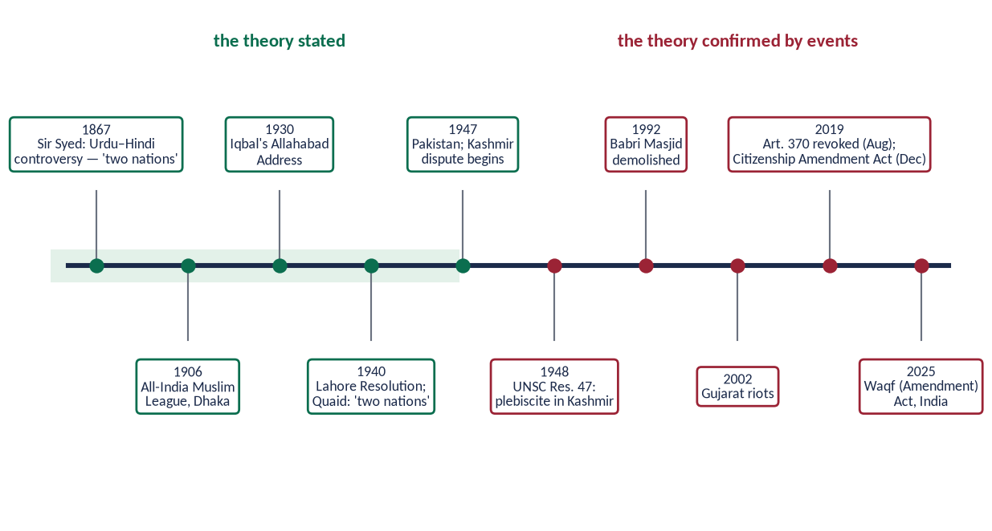
Figure 17 · The Two-Nation Theory — stated (1867–1947) and confirmed by events (1947–2025).

(1) Early recognition
Al-Biruni (Kitab al-Hind, c. 1030) observed that Hindus and Muslims differed in everything — religion, customs and manners — so deeply that they hardly mixed. Shaykh Ahmad Sirhindi (d. 1624) resisted Akbar's attempt to merge religions.

(2) Sir Syed Ahmad Khan
After the Urdu–Hindi controversy (Benares, 1867), Sir Syed concluded that Hindus and Muslims were two nations that could not unite in a common political system, and advised Muslims to protect their separate interests.

(3) The All-India Muslim League (Dhaka, 1906) and separate electorates (1909)

(4) Allama Iqbal — the Allahabad Address (1930)
✦ SCHOLARLY VIEW
Allama Muhammad Iqbal · Presidential Address, All-India Muslim League, Allahabad, 29 December 1930
Iqbal said he would like to see the Punjab, the North-West Frontier Province, Sindh and Baluchistan amalgamated into a single state — a consolidated North-West Indian Muslim state — as the final destiny of the Muslims, at least of North-West India.
➜ The idea of the homeland.

(5) Quaid-e-Azam — the Lahore Resolution (23 March 1940)
✦ SCHOLARLY VIEW
Quaid-e-Azam Muhammad Ali Jinnah · Presidential Address, Lahore, 22 March 1940
“The Hindus and Muslims belong to two different religious philosophies, social customs, literatures. They neither intermarry nor interdine together and, indeed, they belong to two different civilizations which are based mainly on conflicting ideas and conceptions.”
➜ The classic statement of the theory.

✦ SCHOLARLY VIEW
Quaid-e-Azam Muhammad Ali Jinnah · Speech at Aligarh, 8 March 1944
Jinnah said that Pakistan came into being the day the first Hindu became a Muslim in India, long before Muslim rule was established.
➜ Nationhood rests on faith, not territory.

10.4 The justification of the theory
- (a) Religious: Islam is a complete system; Muslims need a state to live by it.
- (b) Cultural: different language (Urdu), dress, food, festivals, law, calendar, heroes.
- (c) Historical: a thousand years of separate identity; separate histories of the same events.
- (d) Political: under a permanent Hindu majority, Muslims would be a permanent minority — as the Congress ministries (1937–39) showed (Muslims' 'Day of Deliverance', 22 December 1939).
- (e) Economic: Muslims were behind in education, jobs and trade; a homeland would protect their interests.

10.5 The plight of Indian Muslims — the theory confirmed
India has about 200 million Muslims (14.2 percent in the 2011 census). Its Constitution promises secularism and equality, but the record shows otherwise:
Year | Event
1992 | Babri Masjid demolished; the Supreme Court (2019) gave the site for a temple
2002 | Gujarat riots — over 1,000 killed, most of them Muslims (official figures)
2006 | Sachar Committee Report found Muslims behind other communities in education, jobs and representation
2015 onwards | Lynchings of Muslims over cow-protection allegations
2019 | Citizenship Amendment Act — fast-track citizenship for non-Muslim migrants from neighbouring countries only; with the proposed National Register of Citizens, feared to target Muslims
2022 | Hijab ban in Karnataka's schools, upheld by the state High Court
2022 onwards | 'Bulldozer' demolitions of Muslim homes and shops after protests
2025 | Waqf (Amendment) Act — changes to the management of Muslim endowments, opposed by Muslim organisations

Muslims are also under-represented in Parliament and public services, and hate speech against them has become common in politics and media.

10.6 The plight of Kashmiri Muslims
- 1947 — the Hindu ruler acceded to India against the will of the Muslim-majority population; war followed.
- UN Security Council Resolution 47 (1948) and later resolutions called for a free and impartial plebiscite — never held.
- 1989 onwards — uprising and heavy military presence; thousands killed, disappearances and human-rights reports (UN OHCHR reports, 2018 and 2019).
- 5 August 2019 — India revoked Articles 370 and 35-A, ending the special status of Jammu and Kashmir; a long communications blackout and mass detentions followed.
- 2020 — new domicile rules allowed non-Kashmiris to settle and buy land — feared as a change in the region's demography.
✦ QURAN
﴿وَمَا لَكُمۡ لَا تُقَٰتِلُونَ فِي سَبِيلِ ٱللَّهِ وَٱلۡمُسۡتَضۡعَفِينَ مِنَ ٱلرِّجَالِ وَٱلنِّسَآءِ وَٱلۡوِلۡدَٰنِ …﴾
“What is wrong with you that you do not fight in the cause of Allah and for the oppressed among men, women and children?” (An-Nisa, Quran)
➜ What is wrong with you that you do not act for the oppressed men, women and children?

✦ QURAN
﴿… وَإِنِ ٱسۡتَنصَرُوكُمۡ فِي ٱلدِّينِ فَعَلَيۡكُمُ ٱلنَّصۡرُ …﴾
“And if they seek your help in the matter of religion, then it is your duty to help them.” (Al-Anfal, Quran)
➜ 'If they seek your help in the matter of religion, then it is your duty to help them.'

10.7 The demands of the Two-Nation Theory today
- (a) Protect Pakistan's ideology — the Objectives Resolution, Article 2A.
- (b) Make Pakistan a model Islamic welfare state — justice, rule of law, prosperity; the best argument for the theory is a successful Pakistan.
- (c) Protect Pakistan's own minorities — Article 36 and the Quaid's 11 August 1947 promise — so that the theory stands for justice, not majoritarianism.
- (d) Support the Kashmiris — politically, diplomatically and morally, through the UN resolutions and the OIC.
- (e) Raise the rights of Indian Muslims — through diplomacy, human-rights forums and the OIC, while respecting international law.
- (f) National unity — Pakistan's provinces and ethnic groups bound by Islam and equal rights.

10.7a The Two-Nation Theory and the Quaid's speech of 11 August 1947
Some ask whether the Quaid's promise of equal citizenship ('you may belong to any religion or caste or creed — that has nothing to do with the business of the State') contradicts the Two-Nation Theory. It does not: the theory was the basis for creating the state; the speech described how the state would treat its citizens. Islam itself requires justice to minorities (the Charter of Madinah); a Muslim state that protects non-Muslims fulfils, rather than denies, its Islamic ideology.

10.7b What the leaders said about Pakistan's ideology
- Quaid, Karachi, 25 January 1948: Islamic principles are 'as applicable to life today as they were 1,300 years ago'; the Constitution would be based on them.
- Liaquat Ali Khan, moving the Objectives Resolution (1949): Pakistan was founded so that Muslims could order their lives according to Islam.
- Iqbal (1930): Islam as 'a people-building force' that had worked in India.

10.8 The objections and their answers
- 'The separation of East Pakistan (1971) disproved the theory.' — No: 1971 was a failure of governance, justice and democracy, not of Muslim identity. Bangladesh became a separate Muslim-majority state, not part of India.
- 'Indian Muslims were left behind.' — The theory was never that all Muslims would migrate; it secured a homeland where Muslims were a majority. The plight of those left behind confirms the danger the theory foresaw.
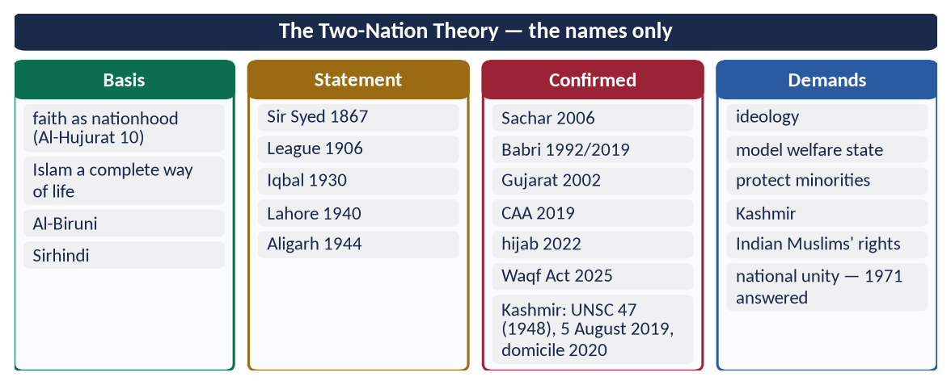
Figure 18 · At a glance — the Two-Nation Theory — the names only. The detail is in the sections above.

Chapter 11 · The Reconstruction of Pakistani Society in the Light of Islamic Teachings
Asked in 2022: 'Explain the Reconstruction of Pakistani Society in the light of Islamic Teachings.'

11.1 The meaning of reconstruction
Reconstruction means rebuilding a society on sound foundations — its individuals, families, institutions and values. Iqbal used the word for the renewal of Muslim thought (The Reconstruction of Religious Thought in Islam, 1930).
✦ SCHOLARLY VIEW
Quaid-e-Azam Muhammad Ali Jinnah · Address at Islamia College, Peshawar, 13 January 1948
Jinnah said that Pakistan was not demanded merely to have a piece of land, but to have a laboratory where Islamic principles could be tried out.
➜ The purpose of Pakistan.

11.2 The constitutional foundation
- Objectives Resolution (12 March 1949) — sovereignty belongs to Allah; Muslims to order their lives according to Islam; minorities' rights; now Article 2A.
- Article 2 — Islam the state religion.
- Article 31 — the state to enable Muslims to live according to Islam; teaching of the Quran; promotion of Islamic values.
- Article 37 and 38 — social justice and the well-being of the people.
- Article 227 — no law repugnant to the Quran and Sunnah.
- Council of Islamic Ideology (Articles 228–230) — advisory body.
- Federal Shariat Court (Article 203C, 1980) — can strike down laws against Islam.

11.3 The problems to be solved
Corruption (CPI 2024: 135th of 180); weak rule of law (WJP 2024: 129th of 142); poverty (about 40 percent); 26 million children out of school; sectarianism and extremism; injustice to women and minorities; elite privilege; family breakdown; moral decline.

11.4 Reconstruction — area by area

(1) The individual — tazkiyah and character
✦ QURAN
﴿… إِنَّ ٱللَّهَ لَا يُغَيِّرُ مَا بِقَوۡمٍ حَتَّىٰ يُغَيِّرُواْ مَا بِأَنفُسِهِمۡۗ …﴾
“Indeed, Allah will not change the condition of a people until they change what is in themselves.” (Ar-Ra'd, Quran)
➜ Allah does not change a people until they change what is in themselves.

Education that joins knowledge and character; mosques and media that teach honesty, punctuality and public duty (Topic 5).

(2) The family
Easy marriage; end of dowry culture; rights of women and children; care of the elderly (Topic 4); Article 35.

(3) Education
✦ QURAN
﴿ٱقۡرَأۡ بِٱسۡمِ رَبِّكَ ٱلَّذِي خَلَقَ﴾
“Recite in the name of your Lord who created.” (Al-Alaq, Quran)
➜ 'Read!' — the first command.

- One quality system instead of three separate tracks (elite English schools, government schools, madrasas).
- Article 25-A — free and compulsory education for ages 5 to 16.
- Science, technology and Islamic ethics together; madrasa reform with modern subjects.

(4) The economy
✦ QURAN
﴿… وَأَحَلَّ ٱللَّهُ ٱلۡبَيۡعَ وَحَرَّمَ ٱلرِّبَوٰاْۚ …﴾
“Allah has permitted trade and forbidden riba (interest).” (Al-Baqarah, Quran)
➜ 'Allah has permitted trade and forbidden riba.'

✦ QURAN
﴿… كَيۡ لَا يَكُونَ دُولَةَۢ بَيۡنَ ٱلۡأَغۡنِيَآءِ مِنكُمۡۚ …﴾
“… so that it does not circulate only among the rich among you.” (Al-Hashr, Quran)
➜ So that wealth does not circulate only among the rich.

- A riba-free economy — the Federal Shariat Court's judgment of 28 April 2022 ordered its elimination; the 26th Amendment (2024) set 1 January 2028 as the target.
- Zakat and Ushr — transparent collection and distribution; social protection through programmes such as the Benazir Income Support Programme.
- Fair taxation; an end to elite privilege; support for small business and agriculture.

(5) Justice and rule of law
✦ QURAN
﴿يَـٰٓأَيُّهَا ٱلَّذِينَ ءَامَنُواْ كُونُواْ قَوَّـٰمِينَ بِٱلۡقِسۡطِ شُهَدَآءَ لِلَّهِ وَلَوۡ عَلَىٰٓ أَنفُسِكُمۡ أَوِ ٱلۡوَٰلِدَيۡنِ وَٱلۡأَقۡرَبِينَۚ …﴾
“O you who believe, stand firmly for justice, as witnesses for Allah, even if it be against yourselves, your parents or your relatives.” (An-Nisa, Quran)
➜ Stand firm for justice, even against yourselves.

Quick and cheap justice; independence of courts; one law for all — 'if Fatimah stole…'.

(6) Governance and accountability
✦ QURAN
﴿إِنَّ ٱللَّهَ يَأۡمُرُكُمۡ أَن تُؤَدُّواْ ٱلۡأَمَٰنَٰتِ إِلَىٰٓ أَهۡلِهَا وَإِذَا حَكَمۡتُم بَيۡنَ ٱلنَّاسِ أَن تَحۡكُمُواْ بِٱلۡعَدۡلِۚ إِنَّ ٱللَّهَ نِعِمَّا يَعِظُكُم بِهِۦٓۗ إِنَّ ٱللَّهَ كَانَ سَمِيعَۢا بَصِيرٗا﴾
“Indeed, Allah commands you to render trusts to whom they are due and when you judge between people to judge with justice. Excellent is that which Allah instructs you. Indeed, Allah is ever Hearing and Seeing.” (An-Nisa, Quran)
➜ Render trusts to whom they are due.

Merit in appointments; transparency; accountability of rulers as in the Caliphate of Umar (RA) (Topic 8).

(7) Social harmony
✦ QURAN
﴿وَٱعۡتَصِمُواْ بِحَبۡلِ ٱللَّهِ جَمِيعٗا وَلَا تَفَرَّقُواْۚ وَٱذۡكُرُواْ نِعۡمَتَ ٱللَّهِ عَلَيۡكُمۡ إِذۡ كُنتُمۡ أَعۡدَآءٗ فَأَلَّفَ بَيۡنَ قُلُوبِكُمۡ فَأَصۡبَحۡتُم بِنِعۡمَتِهِۦٓ إِخۡوَٰنٗا …﴾
“And hold firmly to the rope of Allah all together and do not become divided. Remember Allah's favour upon you: you were enemies, and He brought your hearts together, and by His favour you became brothers.” (Aal-e-Imran, Quran)
➜ 'Hold fast to the rope of Allah together and do not be divided.'

End sectarian hate speech (Paigham-e-Pakistan, 2018); respect for all schools; equal citizenship for minorities (Article 36).

(8) Women and youth
Education, safety and economic participation of women (Article 34); skills and jobs for the young — two-thirds of Pakistanis are under 30.

(9) Media and culture
Media that promotes Islamic and national values, Urdu and regional languages, and truthfulness (Al-Hujurat 6).

(10) The environment
Care of the earth as a trust (Ar-Rahman 7–9); water conservation; climate adaptation after the 2022 floods.

11.4a The roles of the key actors
- The state: make laws according to Articles 31 and 227; ensure justice, welfare and security; be a model of honesty.
- The ulema: preach unity instead of sectarianism; explain Islam's social teachings; support reform.
- Teachers and universities: join knowledge with character; research for national problems.
- Media: truthful, responsible, family-friendly content; counter fake news.
- Civil society and philanthropy: Pakistan is among the most charitable nations — the Edhi Foundation, Shaukat Khanum Memorial Cancer Hospital, Akhuwat (interest-free microfinance) and Saylani Welfare Trust show the Islamic spirit of service in action.
- The family: the first school of values.
✦ HADITH
كُلُّكُمْ رَاعٍ وَكُلُّكُمْ مَسْئُولٌ عَنْ رَعِيَّتِهِ
“Each of you is a shepherd, and each of you is responsible for his flock.” (Al-Bukhari and Muslim)
➜ Reconstruction is everyone's duty.

11.4b A staged roadmap
Stage | Priorities
Immediate (1–2 years) | Rule of law against mobs and hate speech; quick justice in small cases; transparency in Zakat and public spending; digital-media ethics
Medium term (3–5 years) | One quality education system; madrasa reform; riba-free banking transition (target 2028); social protection; women's safety and work
Long term (10+ years) | Research-based economy; accountable institutions; a society of trust and character — the 'laboratory' the Quaid imagined

11.5 The model — the society of Madinah
The Prophet ﷺ built the society of Madinah by: faith and tazkiyah (the mosque), brotherhood (Mu'akhat), a written constitution (the Charter), economic justice (Zakat, fair markets), education (Suffah), rule of law and protection of minorities. These are the blueprint for Pakistan's reconstruction.
Madinah (622–632) | Principle | Pakistan today
Mosque of the Prophet ﷺ | Faith and character | Mosques and schools that build character
Mu'akhat | Brotherhood; integration of refugees | Social solidarity; welfare
Charter of Madinah | Constitution; pluralism | 1973 Constitution; Articles 2A, 20, 36
Suffah | Education for all | Article 25-A; one quality system
Market of Madinah | Honest trade; no riba | Riba-free economy by 2028
'If Fatimah stole' | Rule of law | Independent, fast courts

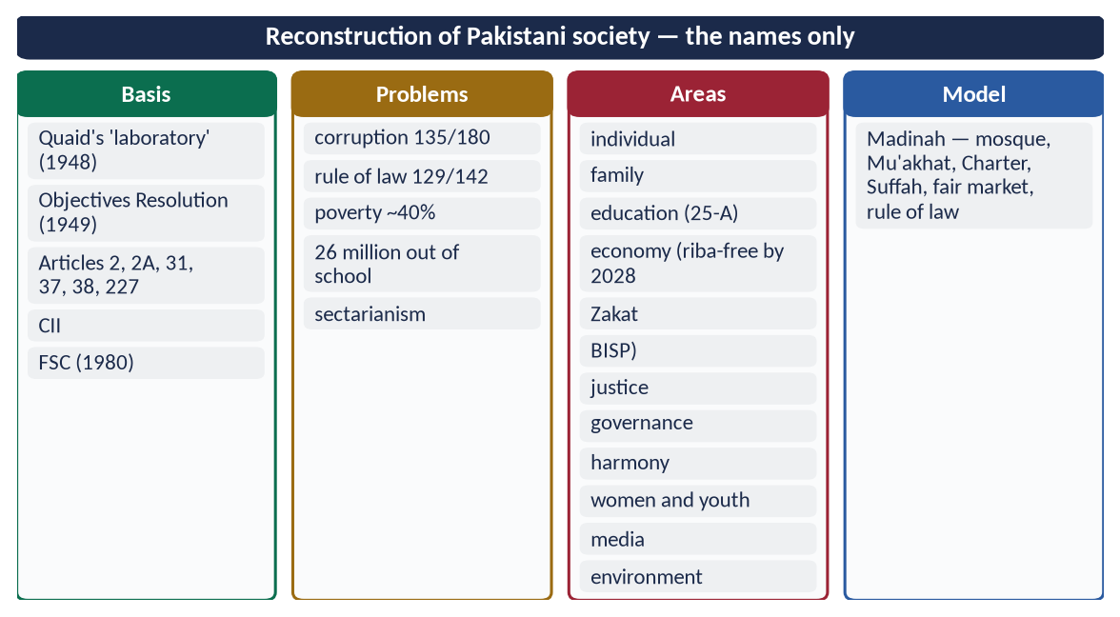
Figure 19 · At a glance — reconstruction of Pakistani society — the names only. The detail is in the sections above.

Part Two — Contemporary Challenges, Narratives and Hot Debates

12.1 The clash of civilizations or the dialogue of civilizations?
Samuel Huntington argued (Foreign Affairs, 1993; The Clash of Civilizations and the Remaking of World Order, 1996) that after the Cold War, conflicts would be between civilizations, and that Islam's borders were 'bloody'. The answer came from dialogue: the UN declared 2001 the Year of Dialogue among Civilizations (on a proposal of Iran's President Khatami), and the Alliance of Civilizations was launched in 2005. The Quranic answer: nations were made 'to know one another' (Al-Hujurat 13), and Muslims are told to argue 'in the best way' (Al-Ankabut 46). Civilizations borrow more than they clash — as Chapter 1 shows.

12.2 Palestine and Gaza
Palestine has been under occupation since 1967; the war in Gaza since October 2023 has killed more than 60,000 Palestinians (Gaza health authorities, mid-2025), most of them women and children, and caused famine conditions. The International Court of Justice ordered provisional measures in South Africa v. Israel (January 2024) and, in an advisory opinion (July 2024), declared Israel's continued occupation of the Palestinian territories unlawful. The OIC and Arab League have called for a ceasefire and a two-state solution on the 1967 borders with Al-Quds al-Sharif as the capital of Palestine. The test for the world is double standards; the test for Muslims is unity and effective diplomacy.

12.3 Kashmir, the Rohingya and Muslims in India
State them factually: UNSC Resolution 47 (1948); 5 August 2019; OHCHR reports (2018, 2019); the Rohingya exodus of 2017 (over 700,000 to Bangladesh) and the ICJ case The Gambia v. Myanmar (2019, brought on behalf of the OIC); in India — the CAA (2019), the Babri verdict (2019), the Waqf (Amendment) Act (2025). The Muslim response: diplomacy, law, human-rights forums, humanitarian aid — and the example of justice to minorities in Muslim countries.

12.4 The OIC — potential and weakness
Potential: 57 states, about a quarter of humanity, energy resources, strategic location, the IsDB. Weakness: non-binding decisions, rivalries among members, no collective security or economic integration, silence or division on key crises. Reform: binding mechanisms, economic integration, a common media and science strategy, a stronger voice at the UN.

12.5 Western cultural influence, brain drain and technological dependence
Western platforms shape the values of Muslim youth; Muslim countries import most of their technology; skilled graduates emigrate (over 800,000 Pakistanis went abroad for work in 2023). The answer: invest in universities and research, create quality content in local languages, and offer the young a future at home.

12.6 Artificial intelligence and the Muslim world
AI will decide economic and military power in this century. The Muslim world must produce, not only consume, it — and bring Islamic ethics (truthfulness, privacy, human dignity, accountability) to its governance.
DEBATE · IS THE WEST THE ENEMY?
No single answer fits: Western states have committed injustices (colonialism, wars, double standards), and Western societies also produced science, human rights, and many who defend Muslims (for example, protests for Gaza across Western cities). The Quranic approach is justice to all and dialogue with all (Al-Ma'idah 8; Al-Mumtahanah 8), with firm opposition to injustice by anyone.

Part Three — The Examiner's Record and Five Likely Questions

13.1 Every question on this topic, 2015–2026
Year | Question | Ch.
2015 Q2 | Explain the concept and structure of the Muslim Ummah and give suggestions for its revival. | 6
2015 Q9 | Give a comparison of Islamic ideology and modern Western thought about present trends of individuality. | 4
2016 Q8 | What are the contemporary challenges of Muslim world? Suggest its solutions in the light of Quran and Sunnah. | 7
2021 Q4 | Comment on the teachings of Islam regarding co-existence in a multi-faith society. | 8
2021 Q5 | Islamophobia is a sign of extremism. Give suggestions for its remedy. | 9
2022 Q7 | Explain the Reconstruction of Pakistani Society in the light of Islamic Teachings. | 11
2025 Q8 | What views are found in today's Muslim circles about Western Civilization? Identify and analyze them. | 3
2026 Q3 | In the light of the plight of Indian and Kashmiri Muslims, discuss the justification and demands of the Two-Nation Theory. | 10
2026 Q4 | Explain how Western civilization has influenced Islamic civilization. Discuss the measures to protect Muslim societies from the negative impacts of Western culture. | 2

All nine are answered in T6QA. Related: extremism as a challenge to the Ummah (2019) and sectarianism in the Muslim world (2026) are taught in Topic 7.

13.2 What the record teaches
- Islam and the West three times (2015, 2025, 2026) — the examiner's rising theme.
- Pakistan-centred questions twice (2022, 2026) — know the Constitution, the Quaid's speeches and current data.
- Two questions in 2021 and two in 2026 — this topic is growing.
- Never asked: Islam's impact on the West; the role of Islam in the modern world.

13.3 Five likely questions
1. Discuss the impact of Islamic civilization on the West with special reference to science, philosophy and Spain.
2. What is the role of Islam in the modern world? Discuss its answers to the problems of modern man.
3. Analyse the causes of the decline of the Muslim Ummah and suggest a plan for its revival.
4. How can the Muslim world meet the challenges of science, technology and globalisation?
5. Discuss the teachings of Islam on inter-faith harmony and dialogue, with reference to Pakistan.

Part Four — The One-Liner Bank

One-liners · Islam's impact on the West
1. Muslim Spain (Al-Andalus) lasted from 711 to 1492.
2. Cordoba's library held about 400,000 volumes.
3. Toledo, taken by Christians in 1085, became Europe's centre of translation from Arabic.
4. The translator of about 87 Arabic works, including Ibn Sina's Canon: Gerard of Cremona.
5. The Norman king of Sicily for whom Al-Idrisi made his world map (1154): Roger II.
6. The Crusades lasted from 1095 to 1291.
7. Liber Abaci (1202), which introduced Arabic numerals to Europe: Fibonacci.
8. 'Algebra' comes from the title of Al-Khwarizmi's book; 'algorithm' from his name.
9. Al-Khwarizmi's algebra was translated into Latin by Robert of Chester in 1145.
10. 'Zero' and 'cipher' come from the Arabic sifr.
11. Kitab al-Manazir (Book of Optics): Ibn al-Haytham.
12. The first to distinguish smallpox from measles: Al-Razi.
13. Al-Tasrif, with some 200 surgical instruments: Al-Zahrawi.
14. Described the pulmonary circulation of blood: Ibn al-Nafis (d. 1288).
15. Europe called Ibn Rushd simply 'The Commentator' (on Aristotle).
16. Al-Qarawiyyin (859) and Al-Azhar (970) are older than Bologna (1088) and Oxford (c. 1096).
17. 'Science is the most momentous contribution of Arab civilization to the modern world': Robert Briffault.
18. Introduction to the History of Science: George Sarton.
19. 'Islam and the West' speech at Oxford (1993): King Charles III, then Prince of Wales.
20. 'Admiral' comes from amir al-bahr; 'arsenal' from dar al-sina'ah; 'tariff' from ta'rif.
21. Cordoba flourished as a caliphate from 929 to 1031.
22. The Tusi couple of Nasir al-Din al-Tusi appears later in the work of Copernicus.
23. Ibn Sina's Canon was taught at Montpellier and Louvain into the 17th century.
24. Tariq ibn Ziyad crossed into Spain in 711; Gibraltar is Jabal Tariq.
25. The Great Mosque of Cordoba was begun in 785.
26. The Khilafat Movement in India: 1919–1924, led by the Ali brothers.
27. The Muslim World League was founded in Makkah in 1962.

One-liners · The West's impact and Muslim views
28. The Battle of Plassey (1757) began British rule in Bengal.
29. Napoleon invaded Egypt in 1798; France took Algeria in 1830.
30. The Sykes–Picot Agreement: 1916; the Balfour Declaration: 1917.
31. The Ottoman Caliphate was abolished in 1924.
32. Sir Syed founded the M.A.O. College, Aligarh, in 1875.
33. Orientalism (1978): Edward Said.
34. 'Those who listen to speech and follow the best of it' — Az-Zumar 18.
35. 'Wisdom is the lost property of the believer' — a famous report in Al-Tirmidhi.
36. Iqbal: approach modern knowledge with a 'respectful but independent attitude'.
37. Atatürk replaced the Arabic script with the Latin in 1928.
38. The Future of Culture in Egypt (1938), urging Egypt to follow Europe: Taha Husayn.
39. Islam at the Crossroads (1934): Muhammad Asad.
40. Man and Nature (1968), on the spiritual roots of the environmental crisis: Seyyed Hossein Nasr.
41. A Common Word Between Us and You (2007) was signed by 138 Muslim scholars.
42. The Amman Message: 2004.
43. Federal Shariat Court judgment on riba: 28 April 2022; target for a riba-free economy: 1 January 2028.
44. Pope Sylvester II (Gerbert) learnt Arabic mathematics in Spain.
45. The founders of the reformist (synthesis) view in Egypt: Jamal al-Din al-Afghani and Muhammad Abduh.

One-liners · Individuality and the role of Islam
46. On Liberty (1859) and the 'harm principle': J. S. Mill.
47. 'Existence precedes essence': Jean-Paul Sartre.
48. The UK appointed a Minister for Loneliness in 2018; Japan in 2021.
49. 'Every soul is held in pledge for what it has earned' — Al-Muddaththir 38.
50. 'Each will come to Him on the Day of Resurrection alone' — Maryam 95.
51. 'The hand of Allah is with the community' — Al-Tirmidhi.
52. Asrar-e-Khudi (1915) and Rumuz-e-Bekhudi (1918): Iqbal.
53. 'Corruption has appeared on land and sea' — Ar-Rum 41.
54. 'Whoever turns from My remembrance — for him is a life of hardship' — Taha 124.
55. He set up the balance (mizan); do not transgress it — Ar-Rahman 7–9.
56. 'If the Hour comes while you hold a sapling, plant it' — Musnad Ahmad.
57. Depression affects about 280 million people (WHO).
58. Oxfam (2024): the richest 1 percent own more than the bottom 95 percent.
59. Iqbal's three needs of humanity: a spiritual interpretation of the universe, spiritual emancipation of the individual, and universal spiritual principles for society.
60. Islamic finance assets worldwide: over 3 trillion dollars.
61. 'In the remembrance of Allah hearts find rest' — Ar-Ra'd 28.

One-liners · The Ummah and its challenges
62. 'This Ummah of yours is one Ummah' — Al-Anbiya 92.
63. A middle nation — Al-Baqarah 143; the best nation — Aal-e-Imran 110.
64. 'A Muslim is the brother of a Muslim; he does not wrong him nor abandon him' — Al-Bukhari and Muslim.
65. The believers are like one body — Muslim.
66. The believer to the believer is like a building — Al-Bukhari and Muslim.
67. The OIC was founded in 1969 at Rabat, after the arson at Al-Aqsa.
68. The OIC has 57 members; its secretariat is in Jeddah.
69. The OIC was renamed Organisation of Islamic Cooperation in 2011.
70. The second OIC summit was held in Lahore in 1974.
71. The Islamic Development Bank was founded in 1975.
72. The Mongols sacked Baghdad in 1258.
73. Iqbal called ijtihad 'the principle of movement in the structure of Islam'.
74. Islamic Military Counter-Terrorism Coalition: 2015.
75. 'Aik hon Muslim Haram ki pasbani ke liye' — Iqbal.
76. The Rohingya exodus from Myanmar: 2017, over 700,000.
77. Pakistan's 2022 floods affected about 33 million people.
78. The OIC science and technology committee: COMSTECH.
79. Over 800,000 Pakistanis went abroad for work in 2023.
80. The Gambia's ICJ case against Myanmar over the Rohingya: 2019.

One-liners · Co-existence and Islamophobia
81. 'Would you compel people until they become believers?' — Yunus 99.
82. 'Do not insult those they invoke besides Allah' — Al-An'am 108.
83. 'Argue with the People of the Book only in the best way' — Al-Ankabut 46.
84. The Marrakesh Declaration on minorities' rights: January 2016.
85. The Document on Human Fraternity (Abu Dhabi): February 2019.
86. The Kartarpur Corridor opened in November 2019.
87. Minorities in Pakistan: about 3.6 percent (Census 2023).
88. Minorities' protection: Article 36; religious freedom: Article 20.
89. The Runnymede Trust report on Islamophobia: 1997.
90. The Christchurch mosque attacks: 15 March 2019 — 51 killed.
91. International Day to Combat Islamophobia: 15 March, UNGA Resolution 76/254 (2022).
92. The Islamophobia resolution was tabled by Pakistan on behalf of the OIC.
93. UNGA Resolution 78/264 (2024) called for a UN Special Envoy on Islamophobia.
94. 'The Clash of Civilizations?' (Foreign Affairs, 1993): Samuel Huntington.
95. French headscarf law in schools: 2004; Swiss minaret ban: 2009.
96. 'Repel evil with what is better' — Fussilat 34.
97. 'We are sufficient for you against the mockers' — Al-Hijr 95.
98. UN Year of Dialogue among Civilizations: 2001.
99. ICJ advisory opinion declaring the occupation of Palestinian territories unlawful: July 2024.
100. The Alliance of Civilizations was launched in 2005.

One-liners · Two-Nation Theory and Pakistan
101. Al-Biruni's study of India: Kitab al-Hind (c. 1030).
102. The Urdu–Hindi controversy that led Sir Syed to speak of 'two nations': 1867, Benares.
103. The All-India Muslim League was founded in 1906, Dhaka.
104. Iqbal's Allahabad Address: 29 December 1930.
105. The Lahore Resolution: 23 March 1940.
106. 'Pakistan came into being the day the first Hindu became a Muslim' — the Quaid, Aligarh, 1944.
107. The Muslims' 'Day of Deliverance' after the Congress ministries: 22 December 1939.
108. UN Security Council Resolution 47 (1948) called for a plebiscite in Kashmir.
109. India revoked Articles 370 and 35-A on 5 August 2019.
110. The Sachar Committee Report on Indian Muslims: 2006.
111. The Babri Masjid was demolished in 1992; the Supreme Court verdict came in 2019.
112. Muslims in India's 2011 census: 14.2 percent.
113. Pakistan as a 'laboratory' for Islamic principles — the Quaid, Islamia College Peshawar, 13 January 1948.
114. The Objectives Resolution: 12 March 1949 (now Article 2A).
115. No law repugnant to the Quran and Sunnah: Article 227.
116. The Federal Shariat Court was established in 1980 (Article 203C).
117. The 26th Amendment (2024) set 1 January 2028 for a riba-free economy.
118. Free and compulsory education for ages 5–16: Article 25-A.
ONE-LINER COUNT
This topic carries 118 one-liners, numbered 1–118. Revise them in blocks of twenty; tick the ones you can answer without looking.

Part Five — Revision Notes · Topic 6
Read these on the night before the paper. Every chapter is broken into its sections; each gives the chain of ideas, the evidence to quote, and the names, dates and numbers. The last line of each chapter tells you which question it serves.

R6.0 The whole topic in one picture
- Two directions: Islam → West (8th–13th c.: teacher) · West → Muslims (16th c. onwards: learner and subject).
- Muslim responses: rejection · Westernisation · synthesis (the balanced middle) · critical engagement · dialogue · conspiracy.
- The Ummah: one body, one Ummah → decline (disunity, no ijtihad, no science, despotism) → revival (Aal-e-Imran 103 + knowledge + governance + Ar-Ra'd 11).
- Pakistan: the Two-Nation Theory (1867 → 1930 → 1940) confirmed by events in India and Kashmir → a duty to reconstruct Pakistan on the Madinah model.
- Tone: firm, factual, balanced — dates, resolutions, reports.

R6.1 Chapter 1 · Islam's impact on the West (due)

1.1 Background
- Europe's early medieval period ↔ the Muslim golden age (Cordoba → Baghdad → Samarkand) → Muslims preserved, translated, corrected, advanced → passed on.
- Evidence: Al-Alaq 1–5 (the pen) · 'seeking knowledge is obligatory' (Ibn Majah).

1.2 Channels (draw the figure)
- Spain 711–1492: Cordoba (library ~400,000) → Toledo after 1085 → Gerard of Cremona (~87 works) → Gerbert (Pope Sylvester II).
- Sicily: Roger II → Al-Idrisi's map (1154) → Frederick II.
- Crusades 1095–1291: contact, goods, ideas.
- Trade: Venice, Genoa, Pisa → paper, sugar, numerals → Fibonacci, *Liber Abaci* (1202).

1.2a Al-Andalus close-up
- 711 Tariq (Jabal Tariq) → 756 Abd al-Rahman I → Great Mosque 785 → 929 Caliphate, Madinat al-Zahra → Al-Hakam II's library → Abbas ibn Firnas (flight), Ziryab (culture), Ibn Tufayl → Alhambra → 1492 Granada falls → Lane-Poole: 'a shining example' to Europe.

1.3 Science
- Numerals and zero (sifr) · Al-Khwarizmi → algebra, algorithm → Robert of Chester (1145) · Omar Khayyam, Al-Tusi.
- Astronomy: Al-Battani · Al-Zarqali · Tusi couple → Copernicus · astrolabe · star names, zenith, nadir, azimuth.
- Ibn al-Haytham → Kitab al-Manazir → light enters the eye, camera obscura, experiment → Roger Bacon, Kepler.
- Jabir → distillation → alchemy, alcohol, alkali, elixir.
- Geography: Al-Idrisi · Al-Biruni (earth's radius) · Ibn Battuta.

1.4 Medicine
- Ibn Sina → Canon → Montpellier, Louvain till the 17th c. · Al-Razi → smallpox/measles, Al-Hawi · Al-Zahrawi → Al-Tasrif, ~200 instruments · Ibn al-Nafis → pulmonary circulation (before Harvey) · bimaristans.

1.5 Philosophy
- Ibn Rushd = 'The Commentator' → Latin Averroism (Paris) · Ibn Sina, Al-Farabi → Aquinas · Al-Ghazali (Algazel) · Aristotle recovered → Renaissance.

1.6–1.7 Education and daily life
- Qarawiyyin 859, Azhar 970 < Bologna 1088, Oxford c. 1096 · ijazah ↔ licentia docendi · paper mill at Xàtiva.
- Crops (rice, sugar, cotton, citrus) · words (tariff, cheque, magazine, arsenal, admiral, checkmate) · lute (al-'ud) · arches.

1.7a–b Why it led — and why it stopped
- Led: 'Read!' · openness (Az-Zumar 18) · patronage (Al-Ma'mun, Bayt al-Hikmah) · paper (Talas 751; Baghdad c. 794) · one language (Arabic) · waqf · religious needs (qiblah, prayer times, inheritance) · Aal-e-Imran 190–191.
- Stopped: ijtihad 'closed' · observatories abandoned (Istanbul 1580) · late printing · trade to the Atlantic.

1.8 Testimony
- Briffault: 'science … most momentous contribution' · Sarton: ages named after Muslim scientists · King Charles (1993): 'the debt our … civilisation owe[s]' · Iqbal: Europe's culture a development of Islam's.
- Exam use: background → channels → fields (table) → testimony → lesson for revival.

R6.2 Chapter 2 · The West's impact on Muslims (2026)

2.1 Reversal
- After the 16th c. Europe rose → Muslims fell → Aal-e-Imran 140 (days alternate) · Ar-Ra'd 11.

2.2 Phases
- Colonial: Plassey 1757 · Egypt 1798 · Algeria 1830 · 1857 · Egypt 1882.
- Ottoman collapse: Sykes–Picot 1916 · Balfour 1917 · Caliphate abolished 1924.
- Post-colonial: new states, Western constitutions and bureaucracies, Cold War.
- Globalisation: IMF, media, internet.

2.3 Gains
- Science and technology · modern education (Aligarh 1875) · constitutions and administration · reform thinkers (Afghani, Abduh, Sir Syed, Iqbal) · women's education, health, rights · Az-Zumar 18.

2.4 Losses
- Political: colonialism, borders, dependence.
- Economic: riba, debt (Al-Baqarah 275), consumerism.
- Ideological: secularism, materialism, relativism.
- Cultural: individualism, family decline, permissiveness, inferiority complex, English elitism (Art. 251).
- Intellectual: Orientalism (Said, 1978) · dual education.

2.4a–c Responses, Pakistan today, globalisation
- Responses: Deoband 1866 (religious learning) · Aligarh 1875 (modern education) · Nadwah 1894 (bridge) · Anjuman-e-Himayat-e-Islam 1884 · Abduh's Azhar reforms.
- Pakistan today: three-track education · foreign media · brand culture and lavish weddings · English as power · IMF and riba (Islamic banking ~ a fifth) · individualism — but also rights awareness and girls' education.
- Globalisation: opportunities (trade, remittances > $30 bn in 2023–24, knowledge, halal and Islamic finance) · threats (uniform culture, dependence, algorithms) · response: participate with identity (Al-Hujurat 13).

2.5 Protective measures (nine)
- Principle: 'wisdom is the lost property of the believer' + Iqbal's 'respectful but independent attitude'.
- Integrated education · strong family · media and PECA/PEMRA · Urdu and Arabic · riba-free economy (FSC 2022, target 2028) · science and research · scholars who understand the age · OIC/ICESCO cooperation · Aal-e-Imran 104.
- Exam use: 2026 → limb 1 = phases + gains + losses (figure); limb 2 = measures (nine headings).

R6.3 Chapter 3 · Muslim views of the West (2025)
- Rejection: West = evil → post-1857 conservatives → +identity / −backwardness, isolation.
- Westernisation: copy all → Atatürk (1924, 1928), Taha Husayn (1938) → +openness / −identity lost, elite–mass split.
- Synthesis: take science, keep values, ijtihad → Sir Syed (1875), Afghani, Abduh, Iqbal (1930) → +balanced / −hard line to draw.
- Critical engagement: critique of materialism → Muhammad Asad (1934), S. H. Nasr (1968) → +depth / −theory only.
- Dialogue: Amman (2004), Common Word (2007, 138 scholars), Human Fraternity (2019) → +peace / −ignored without justice.
- Conspiracy: blame all on the West → +sees injustice / −passivity (Ar-Ra'd 11).
- Pakistan today: all six views present; the Constitution = synthesis (democratic form + Art. 227 content).
- Verdict: middle nation (Al-Baqarah 143) → take the good, reject the harmful, dialogue, reform ourselves; Iqbal's verse 'Khira na kar saka mujhe…'.
- Exam use: 2025 → 'identify' = six headings; 'analyse' = strength and weakness of each + comparison table + verdict.

R6.4 Chapter 4 · Individuality (2015)
- Terms: individuality (affirmed) vs individualism (rejected in its extreme).
- Western rise: Renaissance → Reformation → Locke → Mill, *On Liberty* (1859) harm principle → Sartre → consumer and digital self.
- Present trends: autonomy · rights without duties · secularism · relativism · family decline · loneliness ministers (UK 2018, Japan 2021) · consumerism · redefined identity.
- Islamic view: dignity (Al-Isra 70) · responsibility (Al-Muddaththir 38; Al-An'am 164; Maryam 95) · trustee not owner (An-Nisa 29) · freedom within limits · jama'ah ('hand of Allah', Al-Tirmidhi) · 'one body' (Muslim) · rights with duties · congregational worship.
- Consequences: fewer marriages, divorce · lonely elderly (US Surgeon General, 'loneliness epidemic', 2023) · youth anxiety · decline of community (Putnam, *Bowling Alone*, 2000) · relativism · consumer debt → Al-Jathiyah 23: 'desire as his god'.
- Iqbal: Asrar-e-Khudi (1915) self + Rumuz-e-Bekhudi (1918) community → 'Fard qaim rabt-e-millat se hai…'.
- Comparison table: centre · source · freedom · self-ownership · rights/duties · family · community · accountability · result.
- Exam use: 2015 → define → Western trends → Islamic view → table → Iqbal's balance.

R6.5 Chapter 5 · Role of Islam today (likely)
- Problems: emptiness (WHO ~280 m depressed) · family breakdown · inequality (Oxfam 2024: 1% > 95%) · debt (2008 crisis) · environment (2022 floods, 33 m) · racism · war · relativism · AI without ethics → Ar-Rum 41 · Taha 124.
- Answers: remembrance (Ar-Ra'd 28) · family · Zakat + no riba + circulation · Islamic finance (> $3 trillion) · mizan (Ar-Rahman 7–9), no waste (Al-A'raf 31), the sapling (Ahmad) · equality · peace ethics · fixed morals + ijtihad · knowledge with ethics.
- Ideologies table: capitalism (accept markets, add Zakat, ban riba) · socialism (reject abolition of property/religion) · secularism (religion guides all of life) · liberalism (freedom with responsibility) · nationalism (Ummah above race) · materialism (the unseen) → Iqbal: the third way.
- Appeal today: fast-growing faith (Pew) · converts cite Tawhid, prayer, family · Islamic finance stable in 2008 · fasting, halal.
- Science: Al-Ghashiyah 17–20 · Al-Ankabut 20 · 'will you not reason?' · no Galileo affair (1633) in Islam → research as worship.
- Role: middle nation · best nation · show it in practice · Iqbal's three needs · Shaw.

R6.6 Chapter 6 · The Ummah (2015)
- Concept: umm = purpose → Al-Anbiya 92 / Al-Mu'minun 52 → middle and best nation → brothers (Al-Hujurat 10) → 'does not wrong or abandon him' → 'one body' → faith, not race (Iqbal: 'watan' the new idol; 'Khas hai tarkib mein qaum-e-Rasool-e-Hashmi').
- Structure (draw it): spiritual · social · political (Khilafah 632–1924 → OIC 1969 Rabat, Al-Aqsa arson, 57 states, Jeddah, renamed 2011, Lahore summit 1974) · economic (IsDB 1975) · cultural (Arabic, Hajj, ICESCO).
- Decline: disunity · no ijtihad · no science · despotism · luxury (Ibn Khaldun) · Mongols 1258, Reconquista 1492, colonialism · trade shift → Al-Anfal 46.
- Unity movements: Afghani (d. 1897) · Khilafat Movement 1919–24 (Ali brothers) · Motamar 1926 · Muslim World League 1962 · OIC 1969.
- OIC record: achievements (platform, IsDB, ICESCO, COMSTECH, UNGA 76/254, Rohingya case) vs failures (non-binding, weak trade, wars among members, little effect on Palestine and Kashmir, rivalries).
- Iqbal's vision: a 'League of Muslim Nations' of free, strong states.
- Revival (nine): Quran + ijtihad (Iqbal: 'principle of movement') · unity · science (Al-Mujadilah 11) · shura (Ash-Shura 38) · trade · defence (Al-Anfal 60; IMCTC 2015) · reformed OIC · media and youth · self-change (Ar-Ra'd 11) → Iqbal: 'Aik hon Muslim…'.
- Exam use: 2015 → concept → structure → decline → revival.

R6.7 Chapter 7 · Challenges and solutions (2016)
- Political: disunity · authoritarianism · Palestine (Gaza since Oct 2023, 60,000+ killed by mid-2025) · Kashmir (5 Aug 2019) · civil wars · interventions.
- Economic: poverty · debt · unemployment · weak intra-OIC trade (~1/5).
- Knowledge: literacy (Pakistan ~60%) · low R&D · brain drain (800,000+ in 2023).
- Security: terrorism · refugees · Rohingya 2017.
- Social: sectarianism · youth · drugs · corruption.
- Cultural: Western media · identity · consumerism · religion–science gap.
- External: Islamophobia · double standards.
- Environmental: water · climate (2022 floods; < 1% of emissions).
- Pakistan's role: OIC founder; Lahore summit 1974 · only Muslim nuclear power · Islamophobia resolution 2022 · host of Afghan refugees · UN peacekeeping · mediator → Al-Hujurat 9.
- Palestine case note: Balfour 1917 → Nakba 1948 (~700,000) → 1967, UNSC 242 → Al-Aqsa arson 1969 → Oslo 1993 → Gaza 2023– → ICJ 2024 → Pakistan: two states, pre-1967 borders, Al-Quds capital · Al-Isra 1.
- Solutions table: unity (Aal-e-Imran 103) · shura and trusts (Ash-Shura 38; An-Nisa 58) · Zakat (At-Tawbah 60) · knowledge (Al-Alaq 1) · strength (Al-Anfal 60) · middle path (Al-Baqarah 143) · respect for schools (Al-An'am 159) · rights of the oppressed (Al-Hajj 39) · follow the best (Az-Zumar 18) · mizan → Ar-Ra'd 11 · 'the building' (Al-Bukhari and Muslim).
- Exam use: 2016 → wheel figure → challenges by group → solutions table from Quran and Sunnah.

R6.8 Chapter 8 · Co-existence (2021)
- Meaning: peace, justice, respect with difference — not syncretism.
- Quran (eight): diversity willed (Al-Ma'idah 48) · 'would you compel?' (Yunus 99) · no compulsion · Al-Kafirun · kindness (Al-Mumtahanah 8) · no insulting (Al-An'am 108) · best argument (Al-Ankabut 46), common word (Aal-e-Imran 64) · places of worship (Al-Hajj 40) · know one another (Al-Hujurat 13).
- Sunnah: Charter · Najran · sick Jewish boy, funeral · Abyssinia (minority model) · mu'ahad hadiths (Abu Dawud; Al-Bukhari).
- Modern: Amman 2004 · Common Word 2007 · Marrakesh 2016 · Human Fraternity 2019.
- Pakistan: Arts 20, 22, 36 · 11 Aug 1947 · minorities ~3.6% (2023) · Kartarpur (Nov 2019) · Paigham-e-Pakistan (2018) → challenges (hate speech, mobs, forced-conversion complaints) → solutions (rule of law, curriculum, councils, ulema).
- Muslims as minorities (fiqh al-aqalliyyat): keep covenants (Al-Isra 34) · preserve identity · contribute ('best are the most beneficial' — Al-Tabarani) · rights through law · invite by example (Abyssinia).
- Tools: law · curriculum · dialogue councils · joint relief · religious tourism (Kartarpur, Katas Raj) · media.
- Exam use: 2021 → meaning → Quran → Sunnah → history → modern declarations → Pakistan.

R6.9 Chapter 9 · Islamophobia (2021)
- Meaning: irrational fear/hostility → Runnymede Trust, 1997.
- Forms: Christchurch 15 March 2019 (51) · cartoons 2005 · Quran burnings 2023 · French headscarf 2004, veil 2010 · Swiss minarets 2009 · CAA 2019 · Rohingya 2017.
- Causes: 9/11 · media · Orientalism · far right · Huntington (1993/1996) · migration fear · ignorance · Muslims' conduct.
- 'Sign of extremism': itself extremism (Christchurch manifesto) → cycle of extremisms (draw it) → no collective guilt (Al-An'am 164; Al-Ma'idah 8).
- Remedies: UNGA 76/254 (15 March 2022), tabled by Pakistan for the OIC · 78/264 (2024) Special Envoy · OIC Observatory · laws · education and dialogue · media · Muslim conduct (Fussilat 34; An-Nahl 125) · protect minorities at home · Prophetic response to insult (Al-Hijr 95).
- Diaspora's answer: COVID-19 doctors, food banks, public figures; New Zealand's solidarity after Christchurch → 'the best of people are the most beneficial' (Al-Tabarani).
- Exam use: 2021 → accept the claim and show the cycle → remedies at every level.

R6.10 Chapter 10 · The Two-Nation Theory (2026)
- Meaning: two nations → separate homeland → basis of Pakistan.
- Islamic basis: Al-Hujurat 10 · Al-Anbiya 92 · Al-Kafirun 6 · Islam a complete way of life.
- History (draw the timeline): Al-Biruni (c. 1030) · Sirhindi · Sir Syed 1867 · League 1906 · separate electorates 1909 · Iqbal, Allahabad, 29 Dec 1930 · Congress ministries 1937–39 → Day of Deliverance (22 Dec 1939) · Lahore, 22–23 March 1940 ('two different civilizations') · Aligarh 1944 ('the day the first Hindu became a Muslim').
- Justification: religious · cultural · historical · political · economic.
- Indian Muslims: ~200 m (14.2%, 2011) · Babri 1992/2019 · Gujarat 2002 · Sachar 2006 · lynchings · CAA 2019 · hijab 2022 · bulldozers · Waqf (Amendment) Act 2025.
- Kashmir: 1947 accession · UNSC 47 (1948) plebiscite · 1989 onwards · OHCHR 2018, 2019 · 5 Aug 2019 (Arts 370, 35-A) · domicile rules 2020 → An-Nisa 75 · Al-Anfal 72.
- Demands today: ideology (Art. 2A) · model welfare state · protect own minorities (Art. 36) · Kashmir diplomacy · Indian Muslims' rights via forums · national unity.
- 11 August 1947 and the theory: no contradiction — the theory created the state; the speech set how it treats citizens; justice to minorities is itself Islamic (Charter of Madinah).
- Leaders on ideology: Quaid, Karachi, 25 Jan 1948 (Islamic principles 'as applicable today') · Liaquat, Objectives Resolution 1949 · Iqbal 1930.
- Objections: 1971 = failure of governance, not identity; Bangladesh stayed separate from India · those left behind confirm the danger.
- Exam use: 2026 → justification (history + reasons) → plight as confirmation → demands.

R6.11 Chapter 11 · Reconstruction of Pakistani society (2022)
- Purpose: Quaid, Peshawar, 13 Jan 1948 — a 'laboratory' for Islamic principles.
- Constitution: Objectives Resolution (12 Mar 1949) → Art. 2A · Art. 2 · 31 · 37–38 · 227 · CII (228–230) · FSC 1980 (203C).
- Problems: CPI 135/180 · WJP 129/142 · poverty ~40% · 26 m out of school · sectarianism · injustice to women and minorities · elite privilege.
- Ten areas: individual (Ar-Ra'd 11) · family (Art. 35) · education (Al-Alaq 1; Art. 25-A; one system) · economy (Al-Baqarah 275; Al-Hashr 7; FSC 28 Apr 2022 → 1 Jan 2028; Zakat; BISP) · justice (An-Nisa 135) · governance (An-Nisa 58) · harmony (Aal-e-Imran 103; Art. 36) · women and youth (Art. 34; two-thirds under 30) · media (Al-Hujurat 6) · environment (Ar-Rahman 7–9).
- Actors: state (Arts 31, 227) · ulema (unity) · teachers (character + research) · media (truth) · civil society (Edhi, Shaukat Khanum, Akhuwat, Saylani) · family → 'each of you is a shepherd'.
- Roadmap: immediate (rule of law, quick justice, Zakat transparency, digital ethics) → medium (one education system, madrasa reform, riba-free by 2028, social protection, women) → long (research economy, accountable institutions, trust).
- Madinah model table: Mosque → character · Mu'akhat → solidarity · Charter → constitution, pluralism · Suffah → education · market → riba-free · 'if Fatimah stole' → rule of law.
- Exam use: 2022 → meaning → purpose → constitutional base → problems → ten areas → Madinah model.

R6.12 Part Two · Today
- Clash vs dialogue: Huntington 1993/1996 ↔ UN Year of Dialogue 2001, Alliance of Civilizations 2005 · Al-Hujurat 13.
- Gaza: since Oct 2023, 60,000+ killed (mid-2025) · ICJ provisional measures, Jan 2024 · ICJ advisory opinion, July 2024 (occupation unlawful).
- Rohingya: ICJ, The Gambia v. Myanmar (2019).
- OIC: potential vs weakness → reform.
- Brain drain; AI → produce, don't only consume.
- Debate: is the West the enemy? → justice to all, dialogue with all (Al-Ma'idah 8).

R6.13 The figures to draw in the paper
- Transmission map (Spain, Sicily, Crusades, trade) — Islam's impact on the West.
- Gains and losses — the West's impact.
- Spectrum of views — Muslim views of the West.
- Ummah structure — foundation, five pillars, roof.
- Challenges wheel — Muslim world.
- Cycle of extremisms — Islamophobia.
- Two-Nation timeline — stated and confirmed.

